CIVIL LAW PAPER I · ISLAMABAD HIGH COURT · CIVIL JUDGE-CUM-MAGISTRATE EXAMINATION 2026
Topic 3 · Questions and Model Answers
Contract Act 1872 (general principles, ss. 1–75) — formation, consideration, capacity, free consent, lawful object, terms and remedies — examination questions answered in full
Drawn from KP High Court 2026, Lahore High Court 2017, 2022 and 2023, Sindh High Court 2022 and LHC ASJ 2020 papers

Prepared for: Ihtisham Ul Haq (Roll No. 999)
Paper: Civil Law-I — Monday, 26 October 2026, 2:00 PM to 5:00 PM
Companion volume: Topic 3 — Knowledge Base (read the relevant chapter before each answer)
Format: At a glance · The answer map · Decoding the question · The model answer · Why this answer scores

Contents
How to use these model answers 3
Answer 1 · "All agreements are contracts" — essentials, competence and writing (LHC 2022 · SHC 2022) 5
Answer 2 · Offer, acceptance, invitation to treat, revocation — are bids offers? (LHC 2023) 9
Answer 3 · Farooq and Javaid — negotiations for the sale of a car by e-mail (LHC 2017) 13
Answer 4 · Agreements without consideration are void — the exceptions in s. 25 (LHC 2023) 17
Answer 5 · Agreements by minors and persons of unsound mind and their legal effects (KPHC 2026) 21
Answer 6 · When is consent not free? With illustrations (SHC 2022) 26
Answer 7 · Aslam's mother and the bank guarantee (LHC 2017) 30
Answer 8 · "Consideration" and "object" — the difference, and when they are lawful (LHC ASJ 2020) 35
Answer 9 · Short notes on five concepts (LHC 2022) 39
Answer 10 · Intention of the parties and the relative importance of contractual terms (KPHC 2026) 43
Answer 11 · Breach of a supply contract — damages, remoteness, mitigation and the penalty clause (practice problem) 47
zzTOCENDzz

How to use these model answers

The questions
No past paper of the Islamabad High Court's civil judge examination is publicly available. The questions below come from the papers of courts that set the same or a similar syllabus. The KP High Court 2026 paper follows the IHC syllabus most closely (CPC, Civil Courts Ordinance, Contract Act, Sale of Goods Act).
No. | Question (short title) | Source | Type
1 | "All agreements are contracts" — essentials; who is competent; must contracts be in writing? | LHC 2022, Q. 2 · SHC 2022, Q. 2 | Theory
2 | Offer, acceptance, invitation to treat, revocation — are bids invited by advertisement offers? | LHC 2023, Q. 4 | Theory + application
3 | Farooq and Javaid — e-mail negotiations for the sale of a car | LHC 2017, Q. 2 | Problem
4 | Agreements without consideration are void — the exceptions in s. 25, with illustrations | LHC 2023, Q. 3 | Theory
5 | Agreements by minors and persons of unsound mind and their legal effects | KP High Court 2026, Q. 8 | Theory
6 | When is consent not free? Illustrations | SHC 2022, Q. 2 (alternative) | Theory
7 | Aslam's mother and the bank guarantee — is she liable? | LHC 2017, Q. 1 | Problem
8 | "Consideration" and "object" — the difference, and when they are lawful | LHC ASJ 2020, Q. 1 | Theory
9 | Short notes: agreement vs contract; void vs voidable; promise and reciprocal promises; express and implied authority of an agent; mistake of fact | LHC 2022, Q. 1 | Short notes
10 | Intention of the parties and the relative importance of contractual terms — the courts' approach | KP High Court 2026, Q. 7 | Critical essay
11 | Breach of a supply contract — damages, remoteness, mitigation and the penalty clause | Practice problem (examination style) | Problem

Question 11 is not from a paper. It is a practice problem on ss. 73–74, which is the most-litigated part of the Act and is likely to be examined.

The five parts of every answer
- At a glance — the source, the marks and the exact question.
- The answer map — a one-page picture; each box is one numbered heading of the answer. Draw a rough version in the exam before writing.
- Decoding the question — what the examiner wants.
- The model answer — headings, bare-Act quotations, one case per point, an illustration and a conclusion.
- Why this answer scores — the techniques to copy.
EXAM TIP · Pakistani law wins marks in this topic
The Contract Act in force in Islamabad differs from the Indian Act in places that examiners notice. They are ss. 30A–30C (collateral wagering agreements void; contrast Gherulal Parakh), s. 74 illustrations (d)–(g) (penal interest and acceleration clauses), s. 27 (goodwill exception only) and s. 28 (not amended as in India in 1997). Quote also Art. 17 of the Qanun-e-Shahadat (attestation of financial documents), Art. 127 QSO (burden of good faith) and the Electronic Transactions Ordinance 2002. Each one shows that you have read the law as it applies in Pakistan.

Answer 1 · "All agreements are contracts" — essentials, competence and writing (LHC 2022 · SHC 2022)
AT A GLANCE · LAHORE HIGH COURT 2022 · CIVIL LAW-I · Q. 2 — with SINDH HIGH COURT 2022 · Q. 2 · 20 MARKS
LHC: "All agreements are contracts". Discuss all aspects and their essentials as defined in the Contract Act (IX of 1872). SHC: What agreements are contracts? Who are persons competent to contract? Are all contracts required to be in writing?

The answer map
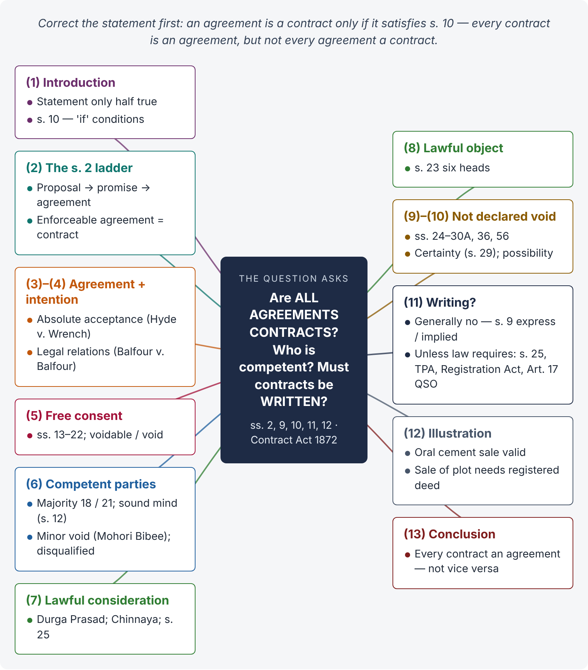
Figure 1 · The answer map: every branch is one numbered heading of the model answer below

Decoding the question
The quotation is incomplete on purpose. Section 10 does not say that all agreements are contracts; it says all agreements are contracts if five conditions are met. The examiner wants you to (i) correct the statement, (ii) build the definitions of s. 2 step by step, (iii) explain each essential with a section and a case, (iv) deal with competence (s. 11) and (v) answer the writing question from the second paragraph of s. 10. A strong answer ends with the maxim "every contract is an agreement, but every agreement is not a contract".

The model answer

1. Introduction — the statement is only half true
The proposition "all agreements are contracts" is not correct as it stands. Section 10 of the Contract Act 1872 provides:
"All agreements are contracts if they are made by the free consent of parties competent to contract, for a lawful consideration and with a lawful object, and are not hereby expressly declared to be void."
So an agreement becomes a contract only when it satisfies the conditions of s. 10. The correct statement is: "All contracts are agreements, but all agreements are not contracts."

2. The building blocks — section 2
- Proposal — "when one person signifies to another his willingness to do or to abstain from doing anything, with a view to obtaining the assent of that other" (s. 2(a)).
- Promise — "a proposal, when accepted, becomes a promise" (s. 2(b)).
- Consideration — what the promisee or any other person does, abstains from or promises at the desire of the promisor (s. 2(d)).
- Agreement — "every promise and every set of promises, forming the consideration for each other" (s. 2(e)).
- Contract — "an agreement enforceable by law" (s. 2(h)).
Hence: proposal + acceptance = promise; promise + consideration = agreement; agreement + enforceability = contract.

3. Essential 1 — offer and acceptance (agreement)
There must be a lawful offer and an absolute and unqualified acceptance, communicated in a usual and reasonable manner (ss. 3–9). A counter-offer is not acceptance (Hyde v. Wrench, (1840) 3 Beav 334); a general offer is accepted by performing its conditions (s. 8; Carlill v. Carbolic Smoke Ball Co., [1893] 1 QB 256).

4. Essential 2 — intention to create legal relations
The phrase "enforceable by law" implies that the parties must intend legal consequences. In social and domestic arrangements the presumption is against such an intention (Balfour v. Balfour, [1919] 2 KB 571 — a husband's promise of a monthly allowance to his wife was not enforceable); in commercial dealings it is presumed.

5. Essential 3 — free consent (ss. 13–22)
Consent means agreeing "upon the same thing in the same sense" (s. 13). It is free when not caused by coercion, undue influence, fraud, misrepresentation or mistake (s. 14). Consent caused by the first four makes the contract voidable (ss. 19, 19A); a bilateral mistake of essential fact makes the agreement void (s. 20).

6. Essential 4 — competent parties (ss. 11–12)

i) Who is competent
"Every person is competent to contract who is of the age of majority according to the law to which he is subject, and who is of sound mind, and is not disqualified from contracting by any law to which he is subject" (s. 11).

ii) Minors
Majority is attained at 18 years (21 where a court has appointed a guardian) — Majority Act 1875, s. 3. A minor's agreement is void ab initio (Mohori Bibee v. Dharmodas Ghose, (1903) ILR 30 Cal 539, PC).

iii) Unsound mind
A person must be "capable of understanding" the contract and "of forming a rational judgment as to its effect upon his interests" at the time (s. 12). A lunatic may contract in a lucid interval; a sane man delirious or drunk cannot (illustrations).

iv) Disqualified persons
Alien enemies (s. 83 CPC), foreign States (s. 86 CPC), insolvents as to their vested property, and bodies acting ultra vires.

7. Essential 5 — lawful consideration
Consideration must be given at the desire of the promisor (Durga Prasad v. Baldeo, (1880) ILR 3 All 221); it may move from the promisee or any other person (Chinnaya v. Ramayya, (1882) ILR 4 Mad 137); it need not be adequate (s. 25 Expl. 2). An agreement without consideration is void (s. 25) except in the three cases listed there.

8. Essential 6 — lawful object (ss. 23–24)
The consideration and object are unlawful if forbidden by law, would defeat any law, are fraudulent, involve injury to person or property, or are immoral or opposed to public policy (s. 23). Illustration (f): paying for a public-service job — void.

9. Essential 7 — not expressly declared void
The Act declares certain agreements void: partly unlawful consideration (s. 24); no consideration (s. 25); restraint of marriage (s. 26), trade (s. 27) or legal proceedings (s. 28); uncertainty (s. 29); wagers (s. 30) and, in Pakistan, agreements collateral to wagers (s. 30A); agreements contingent on impossible events (s. 36); impossible acts (s. 56).

10. Other essentials
- Certainty — "agreements, the meaning of which is not certain, or capable of being made certain, are void" (s. 29).
- Possibility of performance — an agreement to do an act impossible in itself is void (s. 56; illustration (a): discovering treasure by magic).

11. Must contracts be in writing?

i) General rule — no
A contract may be oral, written, or implied by conduct: "In so far as the proposal or acceptance … is made in words, the promise is said to be express. In so far as such proposal or acceptance is made otherwise than in words, the promise is said to be implied" (s. 9). An oral contract is fully valid; the only difficulty is proof.

ii) Exceptions — where another law requires form
The second paragraph of s. 10 saves "any law in force in Pakistan … by which any contract is required to be made in writing or in the presence of witnesses, or any law relating to the registration of documents". Examples:
- s. 25(1) — a promise out of natural love and affection must be written and registered; s. 25(3) — a promise to pay a time-barred debt must be written and signed.
- Transfer of Property Act 1882 — sale of immovable property worth Rs. 100 or more, mortgage, lease from year to year — registered instrument (ss. 54, 59, 107); Registration Act 1908, s. 17.
- Negotiable Instruments Act 1881 — promissory notes, bills and cheques are written instruments.
- Arbitration Act 1940 — an arbitration agreement must be written (s. 2(a)).
- Qanun-e-Shahadat 1984, Art. 17(2)(a) — instruments relating to financial or future obligations "shall be attested by two men, or one man and two women".

12. Illustration
Rehan orally agrees to buy 500 bags of cement from Usman at Rs. 1,300 per bag, delivery in a week. Both are adults of sound mind; the price is consideration; the object is lawful; nothing declares it void. It is a valid contract though oral. But if Rehan agreed to buy Usman's plot in Islamabad, the sale itself would need a registered deed (s. 54 TPA), and a written agreement to sell would need attestation under Art. 17 QSO to be proved as a document.

13. Conclusion
An agreement is a contract only when it has the elements of s. 10 — free consent, competent parties, lawful consideration, lawful object, and no express declaration of voidness — together with certainty, possibility and intention to create legal relations. Writing is not generally required, but s. 10 itself preserves laws that demand writing, attestation or registration. Hence the true rule is: every contract is an agreement, but every agreement is not a contract.

Why this answer scores
- It corrects the quotation in the first line, showing the examiner that you saw the trap.
- The s. 2 ladder shows the structure of the Act; each essential gets a section and a case.
- It answers all three SHC sub-questions (what agreements are contracts, competence, writing) under clear headings.
- The Pakistani form rules — Art. 17 QSO, TPA, Registration Act — lift the answer above textbook level.

Answer 2 · Offer, acceptance, invitation to treat, revocation — are bids offers? (LHC 2023)
AT A GLANCE · LAHORE HIGH COURT 2023 · CIVIL LAW-I · Q. 4 · 20 MARKS
Explain the expressions 'Offer', 'Acceptance', 'Invitation to treat', and 'Revocation of Proposal(s) and Acceptance(s)'. Whether the bid(s) invited from potential bidders through advertisement constitute an offer or simply an invitation to make an offer. Elucidate with illustrations.

The answer map
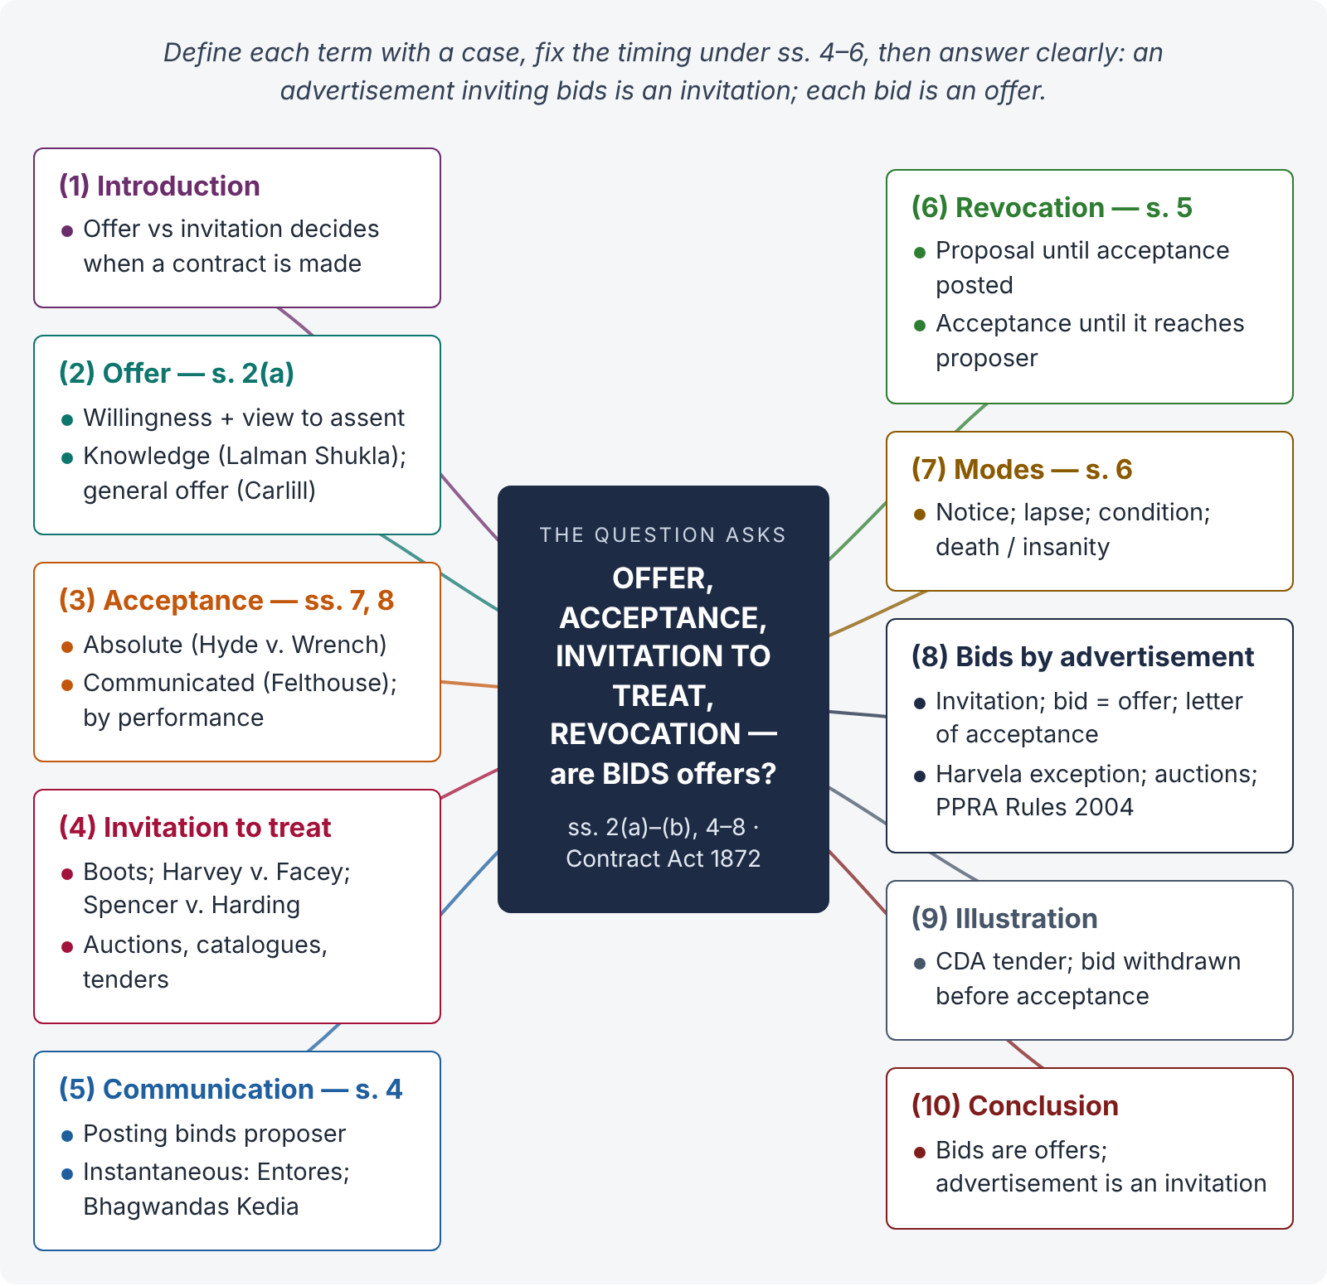
Figure 2 · The answer map: every branch is one numbered heading of the model answer below

Decoding the question
Four definitions, then one application: bids invited by advertisement. The examiner wants (i) s. 2(a) offer and its kinds, (ii) acceptance and its rules (ss. 2(b), 7, 8), (iii) invitation to treat with the leading cases, (iv) revocation under ss. 4, 5 and 6, with the s. 5 illustration, and (v) the clear answer: an advertisement inviting bids is an invitation to treat; each bid is an offer; the letter of acceptance concludes the contract. Pakistani procurement rules add depth.

The model answer

1. Introduction
A contract begins with a proposal and its acceptance. Not every statement that looks like an offer is one: many are only invitations to treat. The distinction decides when the contract is made and who is bound.

2. Offer (proposal) — s. 2(a)

i) Definition
"When one person signifies to another his willingness to do or to abstain from doing anything, with a view to obtaining the assent of that other to such act or abstinence, he is said to make a proposal" (s. 2(a)).

ii) Essentials
- It must be communicated — "the communication of a proposal is complete when it comes to the knowledge of the person to whom it is made" (s. 4). A person who acts in ignorance of the offer cannot accept it (Lalman Shukla v. Gauri Dutt, (1913) 11 ALJ 489).
- Its terms must be certain (s. 29).
- It must show an intention to be bound upon acceptance.
- It may be express or implied (s. 9), specific or general.

iii) General offer
An offer to the world is accepted by anyone who performs its conditions (s. 8). In Carlill v. Carbolic Smoke Ball Co. ([1893] 1 QB 256) the advertisement promising £100, backed by a bank deposit, was a general offer accepted by Mrs Carlill's use of the smoke ball.

3. Acceptance — ss. 2(b), 7, 8
"When the person to whom the proposal is made signifies his assent thereto, the proposal is said to be accepted" (s. 2(b)). To convert a proposal into a promise the acceptance must:
- be absolute and unqualified (s. 7(1)) — a counter-offer rejects the original offer (Hyde v. Wrench, (1840) 3 Beav 334);
- be expressed in a usual and reasonable manner, or the manner prescribed (s. 7(2));
- be communicated — silence is not acceptance (Felthouse v. Bindley, (1862) 11 CBNS 869);
- be made while the offer subsists;
- may be by conduct — performance of the conditions (s. 8).

4. Invitation to treat

i) Meaning
An invitation to treat is a statement inviting others to make offers; it is not itself an offer, and a reply to it is not an acceptance.

ii) Examples and cases
- Display of goods with prices — Pharmaceutical Society v. Boots Cash Chemists ([1953] 1 QB 401): the customer offers at the cash desk; the shop accepts.
- Reply stating a price — Harvey v. Facey ([1893] AC 552, PC): "Lowest price £900" was information, not an offer.
- Auctions — the bid is the offer; the fall of the hammer, acceptance.
- Catalogues, price lists, prospectuses.
- Tender notices — Spencer v. Harding ((1870) LR 5 CP 561): a circular inviting tenders was not an offer to sell to the highest bidder.

iii) Rationale
If displays and advertisements were offers, a seller with limited stock would be bound to everyone who "accepted", and could not choose with whom to deal.

5. When communication is complete — s. 4
Communication | Complete as against the sender | Complete as against the receiver
Proposal | — | When it comes to the knowledge of the offeree
Acceptance | Proposer bound — when put in course of transmission | Acceptor bound — when it comes to the proposer's knowledge
Revocation | When put in course of transmission | When it comes to the knowledge of the other

For instantaneous media (telephone, e-mail), the contract is complete where and when the acceptance is received (Entores v. Miles Far East, [1955] 2 QB 327; Bhagwandas Kedia v. Girdharilal, AIR 1966 SC 543).

6. Revocation of proposal and acceptance — s. 5
"A proposal may be revoked at any time before the communication of its acceptance is complete as against the proposer, but not afterwards. An acceptance may be revoked at any time before the communication of the acceptance is complete as against the acceptor, but not afterwards" (s. 5).
Illustration to s. 5: A proposes by post to sell his house to B; B posts his acceptance. A may revoke before or at the moment B posts the acceptance. B may revoke his acceptance before or at the moment his letter reaches A.

7. Modes of revocation of a proposal — s. 6
A proposal is revoked —
- by notice of revocation communicated by the proposer;
- by lapse of the time prescribed, or of a reasonable time;
- by the acceptor's failure to fulfil a condition precedent to acceptance;
- by the death or insanity of the proposer, if known to the acceptor before acceptance.
Also by rejection or counter-offer. A promise to keep an offer open is not binding without consideration.

8. Are bids invited through an advertisement offers?

i) The answer — an invitation to treat
An advertisement inviting bids is not an offer. It is an invitation to treat — an invitation to make offers. Each bid or tender submitted is an offer. The inviting authority is free to accept any bid or reject all of them. A contract arises only when the authority communicates acceptance of a bid (Spencer v. Harding).

ii) Exception — a promise to accept the highest or lowest bid
If the advertisement promises to award the contract to the highest (or lowest) bidder, that promise may itself be an offer, accepted by submitting the qualifying bid (Harvela Investments v. Royal Trust Co. of Canada, [1986] AC 207 — a promise to accept the highest sealed bid bound the vendor).

iii) Auctions
An advertisement of an auction is not a promise to hold it (Harris v. Nickerson, (1873) LR 8 QB 286). At the auction each bid is an offer, which the bidder may withdraw before the hammer falls.

iv) Revocation of a bid
As a bid is an offer, the bidder may withdraw it before acceptance is communicated (s. 5). But the tender documents usually require a bid security, which may be forfeited under the tender conditions if the bid is withdrawn during its validity period.

v) Public procurement in Pakistan
Public bodies such as the CDA must follow the Public Procurement Regulatory Authority Ordinance 2002 and the Public Procurement Rules 2004. These require open advertisement, evaluation on stated criteria, and reasons for rejecting all bids, and they allow rejection of all bids before acceptance. A contract is concluded when the acceptance of the successful bid is communicated, usually by a letter of acceptance, followed by a formal agreement.

9. Illustration
The CDA advertises: "Sealed bids are invited for constructing a community centre in I-10." Three contractors bid; Ahmad Builders quotes the lowest. Before the CDA decides, Ahmad Builders withdraws its bid. There is no contract: the advertisement was an invitation; the bid was an offer revocable before acceptance (s. 5). The CDA may forfeit the bid security under the tender conditions, but it cannot sue for breach of a contract to build.

10. Conclusion
An offer is a willingness to be bound on acceptance; an acceptance must be absolute and communicated; an invitation to treat only invites offers. A proposal may be revoked until the acceptance is posted, and an acceptance until it reaches the proposer (ss. 4–6). Bids invited by advertisement are therefore invitations to make offers: each bid is an offer, and the contract is made only when the authority communicates acceptance.

Why this answer scores
- Each of the four expressions gets a definition from the Act plus a leading case.
- The s. 4 table and the s. 5 illustration show precise knowledge of timing.
- The bid question is answered directly, with the exception (Harvela) and the auction rule.
- The Pakistani procurement framework makes the answer practical.

Answer 3 · Farooq and Javaid — negotiations for the sale of a car by e-mail (LHC 2017)
AT A GLANCE · LAHORE HIGH COURT 2017 · CIVIL LAW-I · Q. 2 · 20 MARKS
Knowing that Javaid wanted to sell his car so that he could buy a new one, Farooq sent him an e-mail message saying, "I will give you Rs. 1,500,000/- for the car." Javaid replied, "Interesting suggestion. Would you go to Rs. 1,800,000/-?" In response, Farooq sent a further message stating, "Yes. Consider it sold at Rs. 1,800,000/-. No need to reply. I will collect it later in the week." However, Farooq later learned from a mutual friend that Javaid had then accepted a higher offer for the car from someone else. Consequently, he was very surprised when it turned out that Javaid's other deal had fallen through and that Javaid was now expecting Farooq to buy the car. Farooq angrily refused to do so. Discuss the rights, duties, and remedies, if any, of Farooq and Javaid arising out of negotiations for the sale of Javaid's car.

The answer map
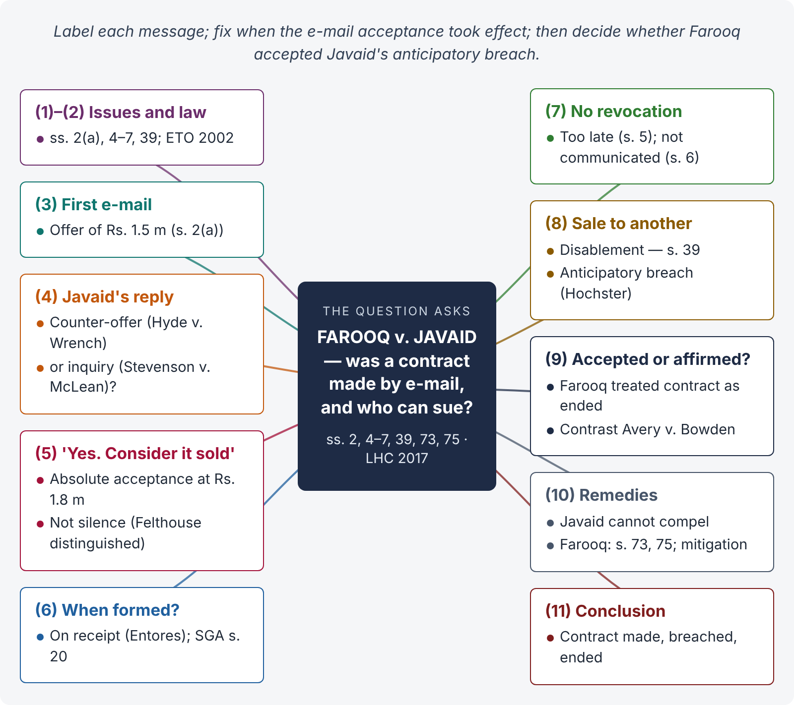
Figure 3 · The answer map: every branch is one numbered heading of the model answer below

Decoding the question
Read every message and label it: offer, counter-offer or inquiry, acceptance. Then decide when the contract (if any) was formed, given that the messages are e-mails. Next, analyse Javaid's sale to someone else: was it a breach (anticipatory repudiation), and did Farooq accept it? Finally, decide whether Javaid can still hold Farooq to the bargain, and state the remedies of each side. The examiner rewards a reasoned conclusion where the facts are open — e.g., whether "Interesting suggestion. Would you go to…?" is a counter-offer or a mere inquiry.

The model answer

1. Issues
- Was Farooq's first e-mail an offer?
- Was Javaid's reply a counter-offer, an inquiry, or an offer in its own right?
- Was Farooq's "Yes. Consider it sold…" an acceptance — and when was the contract formed by e-mail?
- Did Javaid's sale to another buyer amount to anticipatory breach, and what was its effect?
- What are the rights and remedies of each party now?

2. The law in brief
- Proposal — s. 2(a); acceptance must be absolute and unqualified (s. 7(1)); a counter-offer rejects the offer (Hyde v. Wrench).
- Communication — s. 4; for instantaneous media the acceptance is complete when received (Entores v. Miles Far East; Bhagwandas Kedia). E-mails are recognised as valid communications by the Electronic Transactions Ordinance 2002.
- Revocation — ss. 5 and 6.
- Refusal to perform — s. 39: "When a party to a contract has refused to perform, or disabled himself from performing, his promise in its entirety, the promisee may put an end to the contract, unless he has signified, by words or conduct, his acquiescence in its continuance."
- Damages — ss. 73, 75; Sale of Goods Act ss. 55–57.

3. Farooq's first e-mail — an offer
"I will give you Rs. 1,500,000 for the car" is a definite statement of willingness to buy a specific car at a fixed price, made with a view to obtaining Javaid's assent (s. 2(a)). It is an offer, communicated when Javaid read it (s. 4).

4. Javaid's reply — counter-offer or inquiry?

i) Counter-offer view
"Would you go to Rs. 1,800,000?" does not accept Rs. 1,500,000. It proposes different terms (a higher price). It is a counter-offer that rejects and destroys Farooq's original offer (Hyde v. Wrench — an offer of £950 for a farm offered at £1,000 killed the original offer).

ii) Inquiry view
The words "Interesting suggestion" and the question form might suggest a request for information (Stevenson v. McLean (1880) 5 QBD 346 — an inquiry whether credit terms were acceptable did not reject the offer).

iii) The better view
Javaid named a specific price for the specific car and invited Farooq to agree to it. Read objectively, it was a proposal to sell at Rs. 1,800,000 — a counter-offer capable of acceptance. Farooq's original Rs. 1,500,000 offer lapsed (s. 6; rejection).

5. Farooq's second e-mail — acceptance
"Yes. Consider it sold at Rs. 1,800,000. No need to reply. I will collect it later in the week" is an absolute and unqualified assent to Javaid's proposal (s. 7(1)). "No need to reply" dispenses with any further communication from Javaid; it does not make silence the acceptance (the acceptance is Farooq's own message — Felthouse v. Bindley does not apply). The words "I will collect it later in the week" relate to performance, not to a new term.

6. When and where was the contract formed?
E-mail is generally treated as instantaneous communication: the acceptance is complete when it reaches the offeror (Javaid) and is capable of being read (Entores; Bhagwandas Kedia). Even under the postal rule of s. 4, Javaid (the proposer) would be bound when Farooq's e-mail was sent out of his power. On either view, a binding contract of sale for Rs. 1,800,000 was concluded before Javaid accepted the other buyer's offer. As a specific car was sold unconditionally in a deliverable state, property probably passed to Farooq at once (Sale of Goods Act s. 20), though payment and delivery were to follow.

7. Did Javaid revoke his proposal?
A proposal may be revoked only before acceptance is complete as against the proposer (s. 5). Javaid never sent a revocation; his acceptance of a higher offer from a third party, made after Farooq's acceptance, is not a revocation at all. (Even before acceptance, a revocation must be communicated — s. 6(1); news from a mutual friend is at most an indirect communication — Dickinson v. Dodds (1876) 2 Ch D 463.)

8. Javaid's sale to another — anticipatory breach
By agreeing to sell the same car to someone else, Javaid disabled himself from performing his promise to Farooq (s. 39). This is an anticipatory breach (Hochster v. De la Tour, (1853) 2 E & B 678). Farooq then had two options:
- Accept the repudiation — treat the contract as at an end (s. 39) and claim compensation; or
- Affirm the contract — keep it alive and demand performance when due.

9. Did Farooq accept the repudiation?
When Farooq learnt of the other sale, he was "very surprised" when the other deal later fell through, and he refused to buy. The facts suggest that Farooq, on learning of the repudiation, treated the contract as ended — he made other plans and did not affirm. Acceptance of a repudiation need not be formal; it may be by conduct that clearly shows the innocent party treats the contract as over. If so, the contract came to an end when Farooq accepted the repudiation, and Javaid cannot revive it by offering performance later. (Had Farooq affirmed the contract — e.g., by telling Javaid that he still expected the car — the contract would have remained alive for both sides, and Farooq would have been bound to pay: Avery v. Bowden, (1855) 5 E & B 714.)

10. Rights and remedies

i) Javaid
Javaid has no right to compel Farooq to buy. He was the party in breach; Farooq rightly rescinded (s. 39), and "a person who rightly rescinds a contract is entitled to compensation" (s. 75), not liable to perform.

ii) Farooq
- Farooq is discharged from his duty to pay Rs. 1,800,000.
- He may claim compensation for any loss that "naturally arose in the usual course of things" (s. 73) — e.g., the difference between Rs. 1,800,000 and the higher price of a similar car in the market when the breach occurred (SGA s. 57 — damages for non-delivery; s. 73 illus. (a)). If a similar car was available at the same price, damages are nominal.
- He must mitigate his loss (Explanation to s. 73).
- Specific performance is not ordinarily granted for an ordinary car, as damages are adequate (SRA s. 12, Explanation), and in any case Farooq no longer wants it.

11. Conclusion
A contract for the sale of the car at Rs. 1,800,000 was formed when Farooq's e-mail accepting Javaid's counter-offer reached Javaid. Javaid's later sale to another buyer was an anticipatory breach under s. 39, which Farooq accepted by treating the contract as ended. Javaid therefore cannot compel Farooq to buy the car now. Farooq is discharged and may claim compensation under ss. 73 and 75 for any loss proved, subject to mitigation.

Why this answer scores
- Each message is labelled with its legal character, and the doubtful one (counter-offer vs inquiry) is argued both ways before a conclusion.
- The e-mail timing is handled with s. 4, Entores and the ETO 2002.
- The decisive point — acceptance of repudiation vs affirmation (Hochster; Avery v. Bowden) — is identified, which is what the last facts were planted for.
- The answer ends with remedies for both parties, as the question asks.

Answer 4 · Agreements without consideration are void — the exceptions in s. 25 (LHC 2023)
AT A GLANCE · LAHORE HIGH COURT 2023 · CIVIL LAW-I · Q. 3 · 20 MARKS
Agreements without consideration are void. What exceptions are provided in section 25 of the Contract Act 1872? Discuss the illustrations.

The answer map
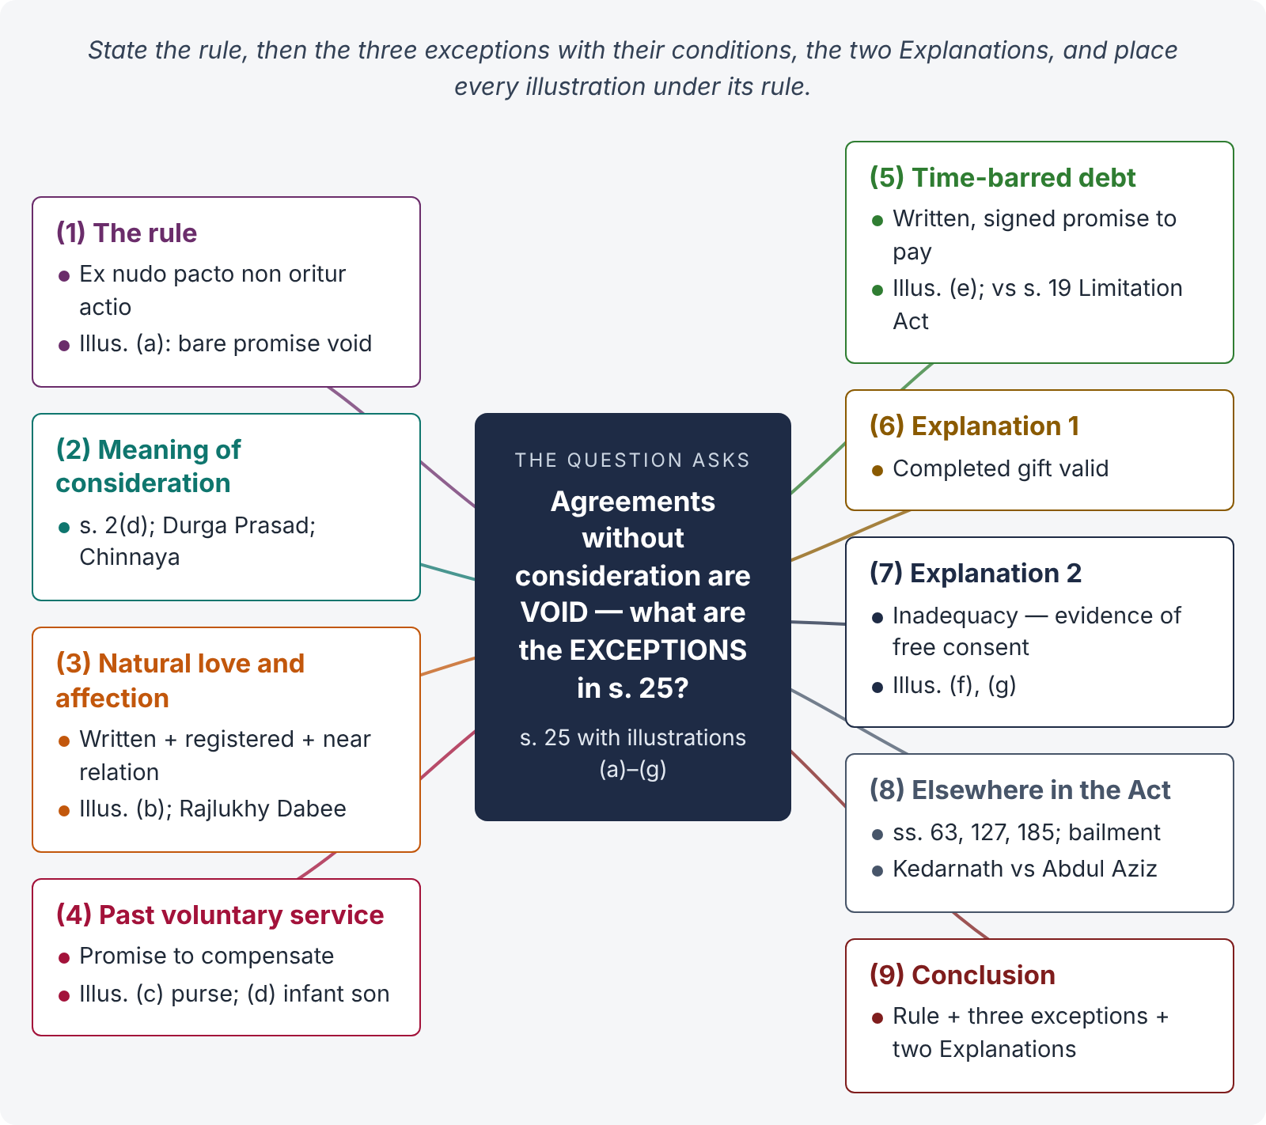
Figure 4 · The answer map: every branch is one numbered heading of the model answer below

Decoding the question
The question has three layers: (i) the rule — consideration is essential and its absence makes an agreement void (ex nudo pacto non oritur actio); (ii) the three exceptions in s. 25 with their conditions; and (iii) the illustrations (a)–(g), which the examiner expressly asks you to discuss. Add the two Explanations and the other no-consideration cases in the Act to complete the picture.

The model answer

1. Introduction — the rule
"An agreement made without consideration is void, unless—" (s. 25). Consideration is the price of the promise (s. 2(d)). The common law expresses the rule in the maxim ex nudo pacto non oritur actio — no action arises from a bare promise. The reason is that the law enforces bargains, not gratuitous promises, which are often made casually and without deliberation.
Illustration (a): "A promises, for no consideration, to give to B Rs. 1,000. This is a void agreement."

2. Meaning of consideration — s. 2(d)
Consideration is the act, abstinence or promise of the promisee or any other person, done at the desire of the promisor, which may be past, present or future. It must be real but need not be adequate (Durga Prasad v. Baldeo, (1880) ILR 3 All 221 — act done at a third party's desire is no consideration; Chinnaya v. Ramayya, (1882) ILR 4 Mad 137 — consideration may move from a third person).

3. Exception 1 — natural love and affection — s. 25(1)

i) Text
An agreement without consideration is valid if "it is expressed in writing and registered under the law for the time being in force for the registration of documents, and is made on account of natural love and affection between parties standing in a near relation to each other".

ii) Conditions
- It is in writing;
- it is registered (Registration Act 1908);
- it is made on account of natural love and affection;
- the parties are in a near relation (e.g., parent and child, husband and wife, brothers).
All four must exist together.

iii) Illustration (b)
"A, for natural love and affection, promises to give his son, B, Rs. 1,000. A puts his promise to B into writing and registers it. This is a contract."

iv) Case
Near relationship alone is not enough; love and affection must be the motive. In Rajlukhy Dabee v. Bhootnath Mookerjee ((1900) 4 CWN 488) a husband's registered promise to pay his wife maintenance, made after quarrels and separation, was held void: there was no natural love and affection behind it.

4. Exception 2 — compensation for past voluntary service — s. 25(2)

i) Text
"…it is a promise to compensate, wholly or in part, a person who has already voluntarily done something for the promisor, or something which the promisor was legally compellable to do."

ii) Conditions
- The promisee did the act voluntarily — without the promisor's request (if it was at his request, it would be ordinary past consideration under s. 2(d));
- the act was done for the promisor, or was something the promisor was legally bound to do;
- the promisor was in existence and capable of contracting when the act was done;
- the promisor later promises to compensate.

iii) Illustrations (c) and (d)
(c) "A finds B's purse and gives it to him. B promises to give A Rs. 50. This is a contract." (d) "A supports B's infant son. B promises to pay A's expenses in so doing. This is a contract." In (d), B was legally bound to maintain his son; A's voluntary act relieved B of that duty.

iv) Rationale
The law gives effect to a moral obligation that the promisor himself has recognised by a later promise.

5. Exception 3 — promise to pay a time-barred debt — s. 25(3)

i) Text
"…it is a promise, made in writing and signed by the person to be charged therewith, or by his agent generally or specially authorized in that behalf, to pay wholly or in part a debt of which the creditor might have enforced payment but for the law for the limitation of suits."

ii) Conditions
- A debt (a definite sum) existed;
- it was enforceable but for limitation — i.e., already time-barred;
- there is an express promise to pay it, wholly or in part (not a mere acknowledgment);
- the promise is in writing and signed by the debtor or his authorised agent.

iii) Illustration (e)
"A owes B Rs. 1,000, but the debt is barred by the Limitation Act. A signs a written promise to pay B Rs. 500 on account of the debt. This is a contract." B may sue for Rs. 500 on the new promise — not for Rs. 1,000.

iv) Distinction from s. 19, Limitation Act
Point | s. 19 Limitation Act | s. 25(3) Contract Act
Timing | Acknowledgment before limitation expires | Promise after limitation has expired
Nature | Acknowledgment of liability is enough | Must be an express promise to pay
Effect | Fresh period for the old debt | A new contract; suit on the new promise

6. Explanation 1 — completed gifts
"Nothing in this section shall affect the validity, as between the donor and donee, of any gift actually made." A gift that has been completed (by delivery or by registered transfer under the Transfer of Property Act, or by declaration, acceptance and delivery of possession under Muslim law — hiba) needs no consideration. Only a promise to make a gift is void.

7. Explanation 2 — inadequacy of consideration
"An agreement to which the consent of the promisor is freely given is not void merely because the consideration is inadequate; but the inadequacy … may be taken into account by the Court in determining the question whether the consent of the promisor was freely given."
Illustration (f): A agrees to sell a horse worth Rs. 1,000 for Rs. 10; consent freely given — a valid contract. Illustration (g): same, but A says his consent was not free — the inadequacy is evidence the court considers on the question of free consent (coercion, undue influence, fraud).

8. Other cases where consideration is not needed
- Agency — "No consideration is necessary to create an agency" (s. 185).
- Gratuitous bailment — valid; the bailee owes duties (ss. 148, 151).
- Guarantee — anything done for the principal debtor is sufficient consideration for the surety (s. 127).
- Remission — the promisee may remit performance or accept any satisfaction (s. 63).
- Charitable subscriptions acted on — Kedarnath Bhattacharji v. Gorie Mahomed ((1886) ILR 14 Cal 64) held such a subscription enforceable once liabilities were incurred on its faith; contrast Abdul Aziz v. Masum Ali ((1914) ILR 36 All 268).

9. Conclusion
Section 25 lays down the rule that an agreement without consideration is void, and then makes three exceptions: a written and registered promise out of natural love and affection between near relatives; a promise to compensate past voluntary service; and a written, signed promise to pay a time-barred debt. Completed gifts are untouched, and inadequacy of consideration does not avoid a contract freely made. The illustrations (a)–(g) are the clearest guide to each rule.

Why this answer scores
- The rule, the three exceptions and the two Explanations each have their own heading, as the question invites.
- Every illustration (a)–(g) is quoted and placed under the right exception — exactly what "discuss the illustrations" means.
- The s. 19 Limitation Act comparison table answers the most common confusion.
- The final section shows wider knowledge (ss. 63, 127, 185; charitable subscriptions) without drifting from the question.

Answer 5 · Agreements by minors and persons of unsound mind and their legal effects (KPHC 2026)
AT A GLANCE · KP HIGH COURT 2026 · CIVIL LAW-I · PART III · Q. 8 · 20 MARKS
Discuss the provisions of law regarding agreements by minors and agreements by persons of unsound mind and their legal effects on the transactions.

The answer map
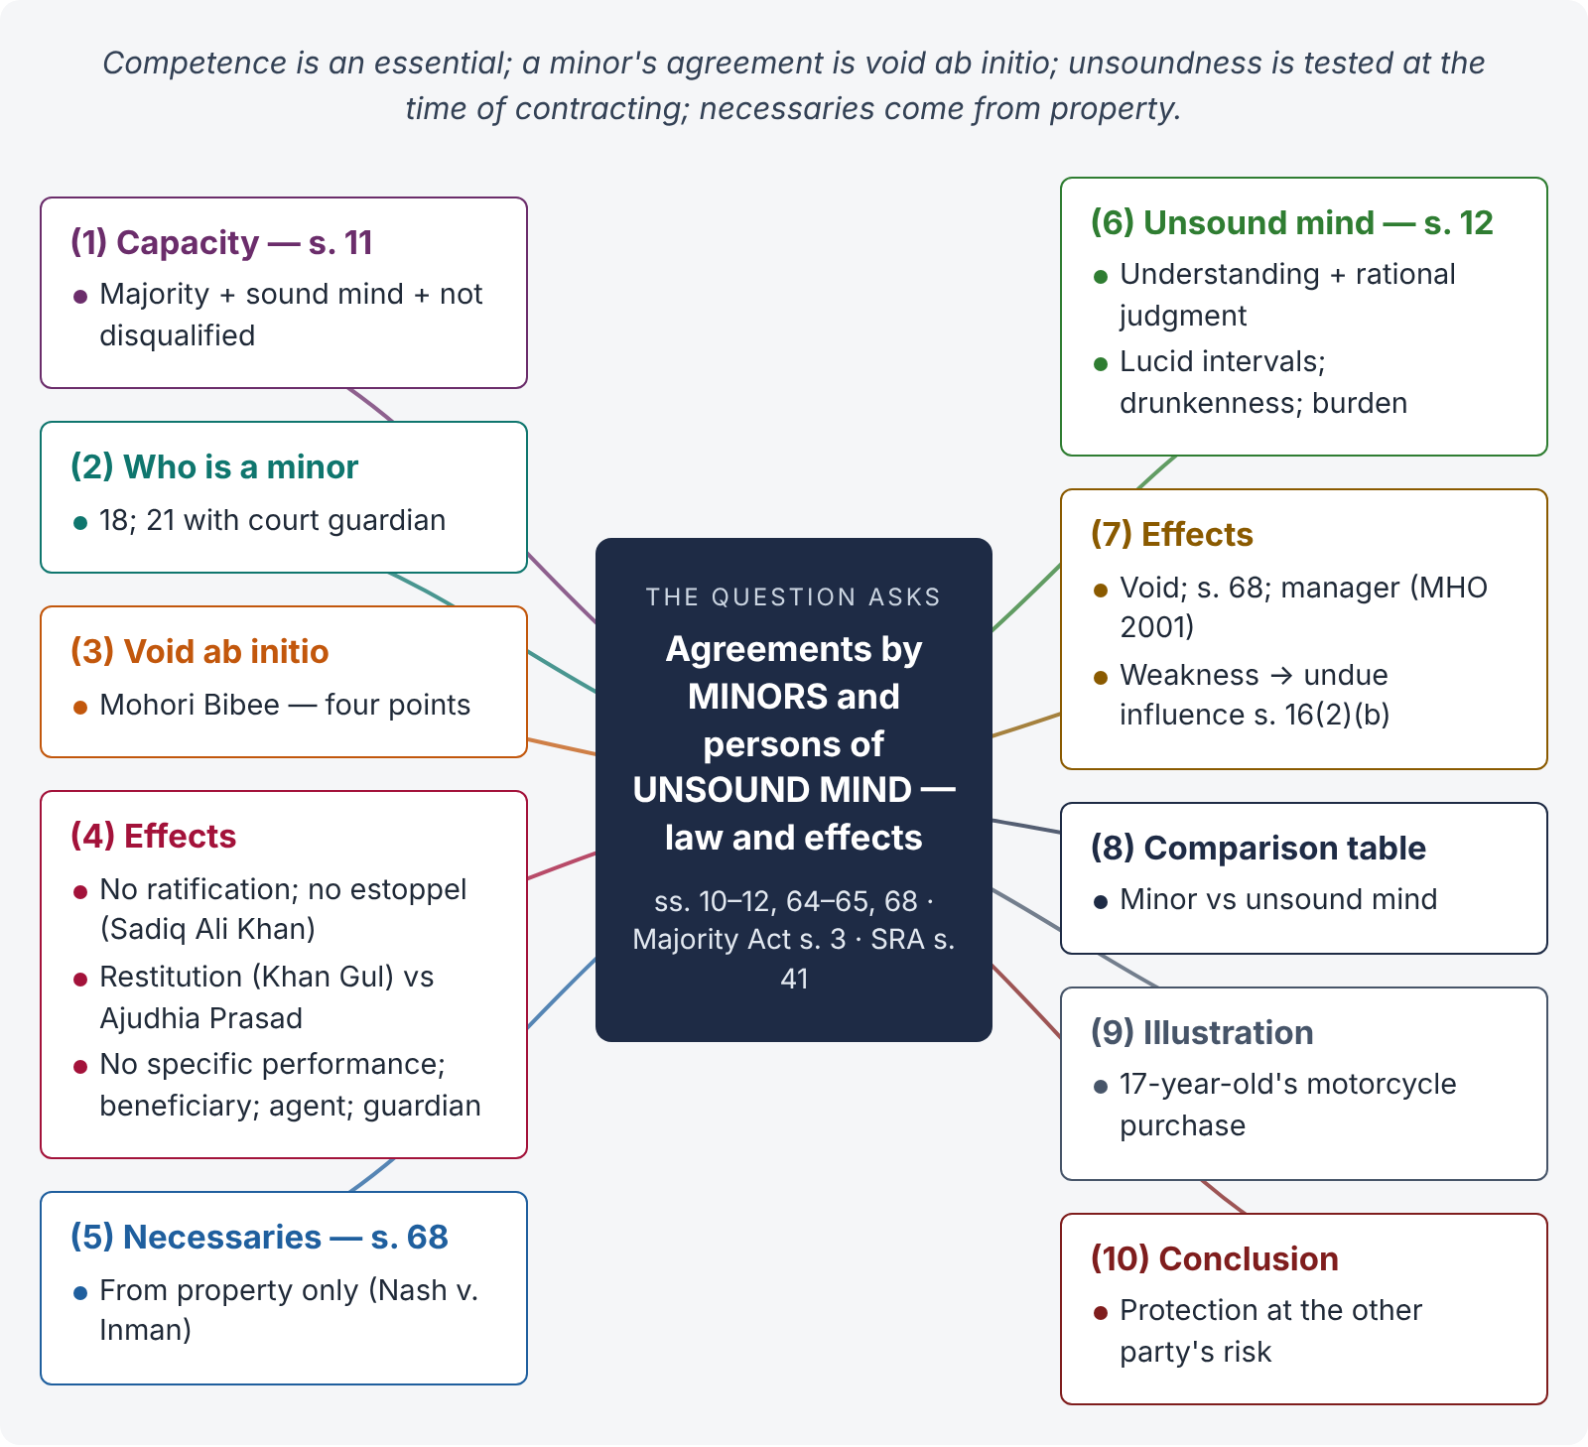
Figure 5 · The answer map: every branch is one numbered heading of the model answer below

Decoding the question
"Provisions of law" means ss. 10, 11, 12, 64, 65 and 68 of the Contract Act, the Majority Act 1875, s. 41 of the Specific Relief Act, and related rules (agency, partnership, negotiable instruments). "Legal effects on the transactions" means: is the agreement void or voidable? Can it be ratified? Can money paid be recovered? Can the minor be estopped? What about necessaries? Answer both halves (minor and unsound mind) with cases.

The model answer

1. Introduction — capacity is an essential of contract
Section 10 requires that a contract be made by "parties competent to contract". Section 11 defines competence:
"Every person is competent to contract who is of the age of majority according to the law to which he is subject, and who is of sound mind, and is not disqualified from contracting by any law to which he is subject."
The law protects minors and persons of unsound mind because they cannot properly judge their own interests.

2. Who is a minor
Under the Majority Act 1875, s. 3, a person attains majority on completing 18 years; if a guardian of his person or property has been appointed by a court, or his property is under a Court of Wards, at 21 years. Matters of marriage, dower, divorce and adoption are excluded (s. 2).

3. Nature of a minor's agreement — void ab initio
The Act says a minor is "not competent" but not what the effect is. The Privy Council settled it in Mohori Bibee v. Dharmodas Ghose ((1903) ILR 30 Cal 539):
- A minor mortgaged his house to a money-lender for Rs. 20,000, of which about Rs. 8,000 was advanced; the lender's agent knew of the minority.
- Held: a minor's agreement is absolutely void, not merely voidable, because competence is an essential of contract (ss. 10–11).
- The lender could not recover the money under s. 64 or s. 65, which presuppose a contract between competent parties.
- Relief under s. 41, Specific Relief Act (compensation on cancellation) is discretionary and was refused because the lender knew of the minority.

4. Effects of a minor's agreement

i) No enforcement against the minor
Neither the minor nor his estate can be sued on the agreement.

ii) No ratification on majority
A void agreement cannot be ratified. A fresh promise for fresh consideration after majority is a new contract.

iii) No estoppel
A minor who misrepresents his age is not estopped from pleading minority (Sadiq Ali Khan v. Jai Kishori, AIR 1928 PC 152). Estoppel (Art. 114, Qanun-e-Shahadat 1984) cannot override the statute.

iv) Restitution of benefits obtained by fraud
Equity prevents a minor from using minority as a sword. In Khan Gul v. Lakha Singh (AIR 1928 Lah 609, FB), a minor who obtained Rs. 17,500 by falsely posing as an adult was ordered to refund it, though the sale could not be enforced. The Allahabad Full Bench in Ajudhia Prasad v. Chandan Lal (AIR 1937 All 610) limited restitution to cases where the minor is the plaintiff. The English rule allows only traceable property to be recovered (R. Leslie Ltd. v. Sheill, [1914] 3 KB 607).

v) No specific performance either way
Not against the minor; nor in his favour, for want of mutuality (Mir Sarwarjan v. Fakhruddin Mahomed Chowdhury, (1912) ILR 39 Cal 232, PC).

vi) Minor as beneficiary
A minor may be a promisee, payee or endorsee (s. 26, Negotiable Instruments Act), or a mortgagee, and can enforce a contract under which he has fully performed (Raghava Chariar v. Srinivasa, (1917) ILR 40 Mad 308, FB).

vii) Minor as agent and in partnership
A minor may be an agent, binding the principal, though not liable to the principal (s. 184). He may be admitted to the benefits of a partnership with all partners' consent (s. 30, Partnership Act 1932).

viii) Guardian's contracts
A contract by the minor's guardian, within his powers and for the minor's benefit, binds the minor's estate (Subrahmanyam v. Subba Rao, AIR 1948 PC 95), subject to court permission for alienations by court-appointed guardians (s. 29, Guardians and Wards Act 1890).

ix) Torts
A minor is liable for torts, but not where the tort is the contract in disguise (Leslie v. Sheill).

5. Necessaries — s. 68
"If a person, incapable of entering into a contract, or any one whom he is legally bound to support, is supplied by another person with necessaries suited to his condition in life, the person who has furnished such supplies is entitled to be reimbursed from the property of such incapable person."
- The liability is quasi-contractual, limited to the minor's property — no personal liability.
- "Necessaries" are goods and services suited to his status and his actual needs at the time — food, clothes, education, medical care, legal defence of his property; not luxuries or an excess supply (Nash v. Inman, [1908] 2 KB 1 — eleven fancy waistcoats).

6. Persons of unsound mind — s. 12
"A person is said to be of sound mind for the purpose of making a contract if, at the time when he makes it, he is capable of understanding it and of forming a rational judgment as to its effect upon his interests. A person who is usually of unsound mind, but occasionally of sound mind, may make a contract when he is of sound mind. A person who is usually of sound mind, but occasionally of unsound mind, may not make a contract when he is of unsound mind."

i) The test
The two-part test — understanding and rational judgment — is applied at the time of contracting.

ii) Illustrations
(a) A patient in a lunatic asylum may contract in lucid intervals. (b) A sane man delirious with fever or so drunk that he cannot understand cannot contract while that state lasts.

iii) Burden of proof
Sanity is presumed; the person alleging unsoundness must prove it. If a person is shown to be usually of unsound mind, the burden shifts to the one who relies on a lucid interval.

7. Effects of an agreement by a person of unsound mind
- It is void, applying the same reasoning as Mohori Bibee (ss. 10–12).
- Necessaries supplied to him or his dependants are reimbursable from his property (s. 68, illustrations (a) and (b)).
- Where a manager or guardian of his property has been appointed under the Mental Health Ordinance 2001, transactions must go through that manager.
- Partial weakness of mind that falls short of s. 12 may still make the contract voidable for undue influence, where the other party dominated a person "whose mental capacity is temporarily or permanently affected by reason of age, illness, or mental or bodily distress" (s. 16(2)(b)).

8. Comparison
Point | Minor | Person of unsound mind
Incapacity | Permanent until majority (18 / 21) | May be temporary; lucid intervals allowed
Test | Age | Understanding + rational judgment at the time (s. 12)
Effect | Void ab initio (Mohori Bibee) | Void
Necessaries | From property (s. 68) | From property (s. 68)
Ratification | Not possible | Not possible, but may contract afresh when sane
Agent | Can be an agent (s. 184) | Cannot be responsible as agent (s. 184)

9. Illustration
Hamza, aged 17, buys a motorcycle worth Rs. 300,000 on instalments from a dealer in Rawalpindi, stating that he is 19. He pays Rs. 50,000 and defaults. The agreement is void; the dealer cannot sue for the price or rely on estoppel. But the court may order Hamza to return the motorcycle (traceable property obtained by fraud — Khan Gul; Leslie v. Sheill). If the motorcycle was a necessary for his travel to college, given his condition in life, the dealer may be reimbursed its reasonable value from Hamza's property (s. 68).

10. Conclusion
A minor's agreement is void ab initio; it cannot be enforced, ratified or made binding by estoppel, though a minor may be ordered to restore benefits obtained by fraud, and is liable for necessaries out of his property. A person of unsound mind is in the same position, except that he may contract validly during a lucid interval, and weakness short of unsoundness is dealt with by the law of undue influence. These rules protect the vulnerable at the cost of those who deal with them — who act at their own risk.

Why this answer scores
- It quotes ss. 11, 12 and 68 and states the Majority Act rule precisely.
- Mohori Bibee is given its four points, and the "effects" are listed one by one as the question requires.
- The Lahore Full Bench (Khan Gul) is a Pakistani-heritage authority examiners look for.
- The comparison table and the illustration show application, not just recall.

Answer 6 · When is consent not free? With illustrations (SHC 2022)
AT A GLANCE · SINDH HIGH COURT 2022 · CIVIL LAW · Q. 2 (alternative) · 20 MARKS
Under what circumstances can it be said that a contract is not by free consent? Give illustrations.

The answer map
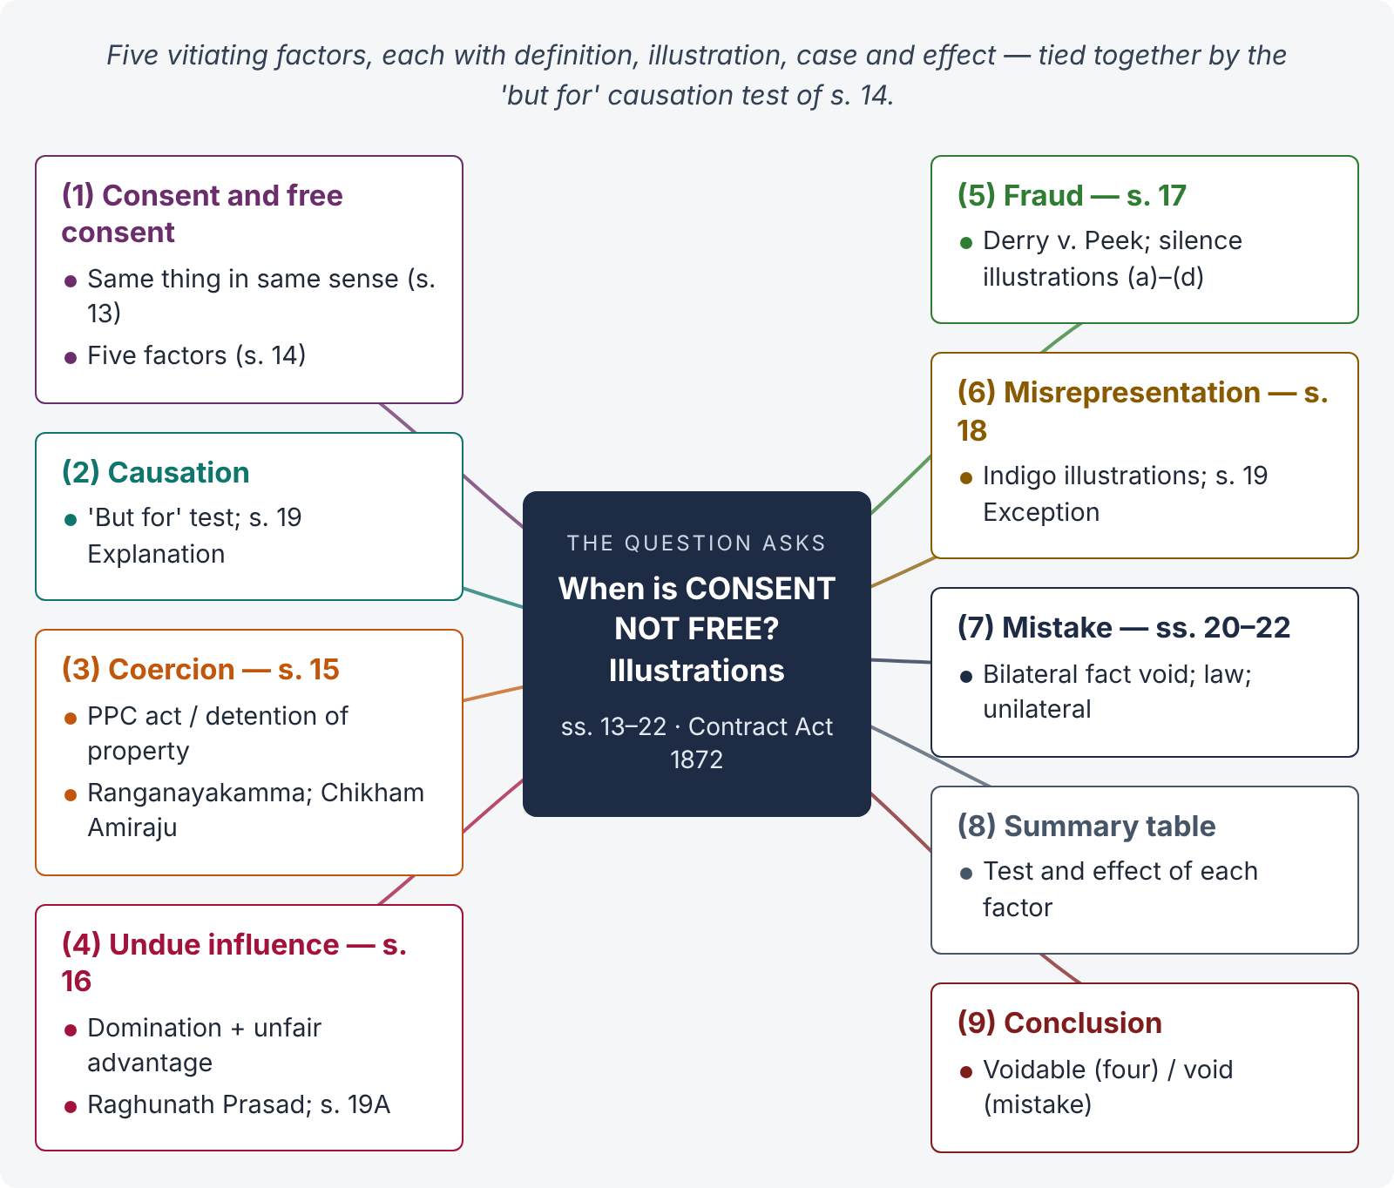
Figure 6 · The answer map: every branch is one numbered heading of the model answer below

Decoding the question
"Circumstances" = the five factors of s. 14 — coercion, undue influence, fraud, misrepresentation and mistake — each with its definition, ingredients, a case and an illustration (use the Act's own). Explain the "but for" causation test and the effect of each (voidable or void), including the s. 19 Exception. A table at the end is efficient.

The model answer

1. Introduction — consent and free consent
"Two or more persons are said to consent when they agree upon the same thing in the same sense" (s. 13). Consent is free when it is not caused by coercion (s. 15), undue influence (s. 16), fraud (s. 17), misrepresentation (s. 18) or mistake (ss. 20–22) (s. 14). Free consent is an essential of a contract (s. 10).

2. Causation — the "but for" test
"Consent is said to be so caused when it would not have been given but for the existence of such coercion, undue influence, fraud, misrepresentation or mistake" (s. 14). A defect that did not influence the decision does not affect the contract (s. 19 Explanation).

3. Coercion — s. 15

i) Definition
"'Coercion' is the committing, or threatening to commit, any act forbidden by the Pakistan Penal Code or the unlawful detaining, or threatening to detain, any property, to the prejudice of any person whatever, with the intention of causing any person to enter into an agreement." It is immaterial whether the PPC is in force where the coercion is used (Explanation).

ii) Illustration and cases
Statutory illustration: A, on an English ship on the high seas, makes B agree by criminal intimidation; A sues at Karachi — coercion. Ranganayakamma v. Alwar Setti ((1889) ILR 13 Mad 214): a young widow made to adopt a boy before her husband's body could be removed for cremation — coercion. Chikham Amiraju v. Seshamma ((1917) ILR 41 Mad 33): threat of suicide held coercion (then an offence).

iii) Effect
Voidable at the option of the coerced party (s. 19); money paid under coercion is recoverable (s. 72).

4. Undue influence — s. 16

i) Definition
A contract is induced by undue influence "where the relations subsisting between the parties are such that one of the parties is in a position to dominate the will of the other and uses that position to obtain an unfair advantage" (s. 16(1)). Domination is presumed where there is real or apparent authority, a fiduciary relation, or the other's mental capacity is affected by age, illness or distress (s. 16(2)). If the transaction is unconscionable, the burden shifts to the dominant party (s. 16(3)).

ii) Illustrations and case
(a) A father obtains from his son, just of age, a bond for more than is due; (b) a medical attendant extracts an unreasonable fee from an old, sick patient; (c) a village money-lender's unconscionable fresh loan — burden on lender; (d) a bank's high rate in a tight money market — not undue influence. Raghunath Prasad v. Sarju Prasad ((1923) 51 IA 101, PC) laid down the three questions: domination, use of the position, and burden on unconscionability.

iii) Effect
Voidable; may be set aside absolutely or on just terms if the party has received a benefit (s. 19A; illus. (b) — repay Rs. 100 with reasonable interest).

5. Fraud — s. 17

i) Definition
Acts by a party (or with his connivance, or by his agent) with intent to deceive or to induce a contract: a false suggestion of fact by one not believing it; active concealment; a promise without intention to perform; any other act fitted to deceive; or acts the law declares fraudulent.

ii) Silence
"Mere silence … is not fraud, unless … it is the duty of the person keeping silence to speak, or unless his silence is, in itself, equivalent to speech." Illustrations: (a) a horse known to be unsound sold at auction without a word — not fraud; (b) the buyer is the seller's daughter just of age — duty to speak; (c) "If you do not deny it, I shall assume the horse is sound" — silence equals speech; (d) traders with private price information — no duty.

iii) Case and effect
Derry v. Peek ((1889) 14 App Cas 337): fraud requires a false statement made knowingly, without belief in its truth, or recklessly. Effect: voidable, or the party may affirm and insist on being placed as if the statement were true (s. 19; illus. (c) — estate said to be free from mortgage); damages in deceit.

6. Misrepresentation — s. 18

i) Definition
(1) A positive assertion, not warranted by the maker's information, of what is untrue, though he believes it; (2) a breach of duty that, without intent to deceive, gains an advantage by misleading another; (3) innocently causing a party to make a mistake as to the substance of the subject matter.

ii) Illustration and effect
s. 19 illus. (a): A falsely represents that 500 maunds of indigo are made yearly at his factory — voidable. Illus. (b): B checks the accounts which show 400 maunds, and still buys — not voidable (Exception: the truth was discoverable with ordinary diligence; and the statement did not cause the consent).

7. Mistake — ss. 20–22
- Bilateral mistake of essential fact — the agreement is void (s. 20). Illustrations: cargo already lost on its way to Karachi; a horse already dead; a life estate when the life had ended. An erroneous opinion about value is not a mistake of fact (Explanation). Couturier v. Hastie ((1856) 5 HLC 673).
- Mistake of Pakistani law — not voidable; foreign law — like a mistake of fact (s. 21).
- Unilateral mistake — not voidable (s. 22), except mistake as to identity where it is vital (Cundy v. Lindsay, (1878) 3 App Cas 459) and non est factum (Foster v. Mackinnon, (1869) LR 4 CP 704).

8. Summary table
Factor | Key test | Effect
Coercion (s. 15) | PPC act or unlawful detention of property | Voidable (s. 19); refund (s. 72)
Undue influence (s. 16) | Domination + unfair advantage; burden shift | Voidable; set aside on terms (s. 19A)
Fraud (s. 17) | Intentional deception; silence only with duty | Voidable or affirm; damages
Misrepresentation (s. 18) | Innocent but unwarranted false statement | Voidable or affirm; s. 19 Exception
Mistake (ss. 20–22) | Bilateral essential fact | Void; law / unilateral — no relief

9. Conclusion
Consent is not free when it is caused by coercion, undue influence, fraud, misrepresentation or mistake. The first four make the contract voidable at the option of the party misled or pressured; a bilateral mistake of essential fact makes the agreement void. The law thus protects the genuineness of the will behind every contract.

Why this answer scores
- It begins with s. 13 and s. 14, including the often-missed "but for" causation rule.
- Each factor has definition → illustration → case → effect — a repeatable pattern.
- The statutory illustrations are used extensively, as the question asks for illustrations.
- The summary table gives the examiner the whole picture at a glance.

Answer 7 · Aslam's mother and the bank guarantee (LHC 2017)
AT A GLANCE · LAHORE HIGH COURT 2017 · CIVIL LAW-I · Q. 1 · 20 MARKS
Aslam is a young businessman who has just graduated from University. He decides to start up a business, which organizes marriage functions within Lahore — seeing an opportunity in a local market. Aslam approaches Bank for obtaining a loan to secure office premises. The bank is impressed by his business plan, but given his inexperience, is only willing to lend him Rs. 20.00 Million, if the loan is guaranteed. One evening, Aslam and a representative from Bank go to visit Aslam's mother in a village. Aslam's mother (Sakina) is seventy years old and she has been in the village for nine years after a car accident in which her husband was killed. As a result of the accident, she suffered a major brain hemorrhage and has lost most memories of her life, and suffers from some language comprehension difficulties. She is very passive and she was heavily reliant on her husband for emotional and financial support. Aslam shows her mother the contract and tells her: "The Bank just wants to make sure that everything will be okay with my new business. They just want to make sure that someone will pay them if it goes broke, but I am sure it won't come to that. Can you just sign here?" Her signatures are obtained on the deed of guarantee. Is Aslam's mother liable under the guarantee? Explain your opinion with reasons.

The answer map
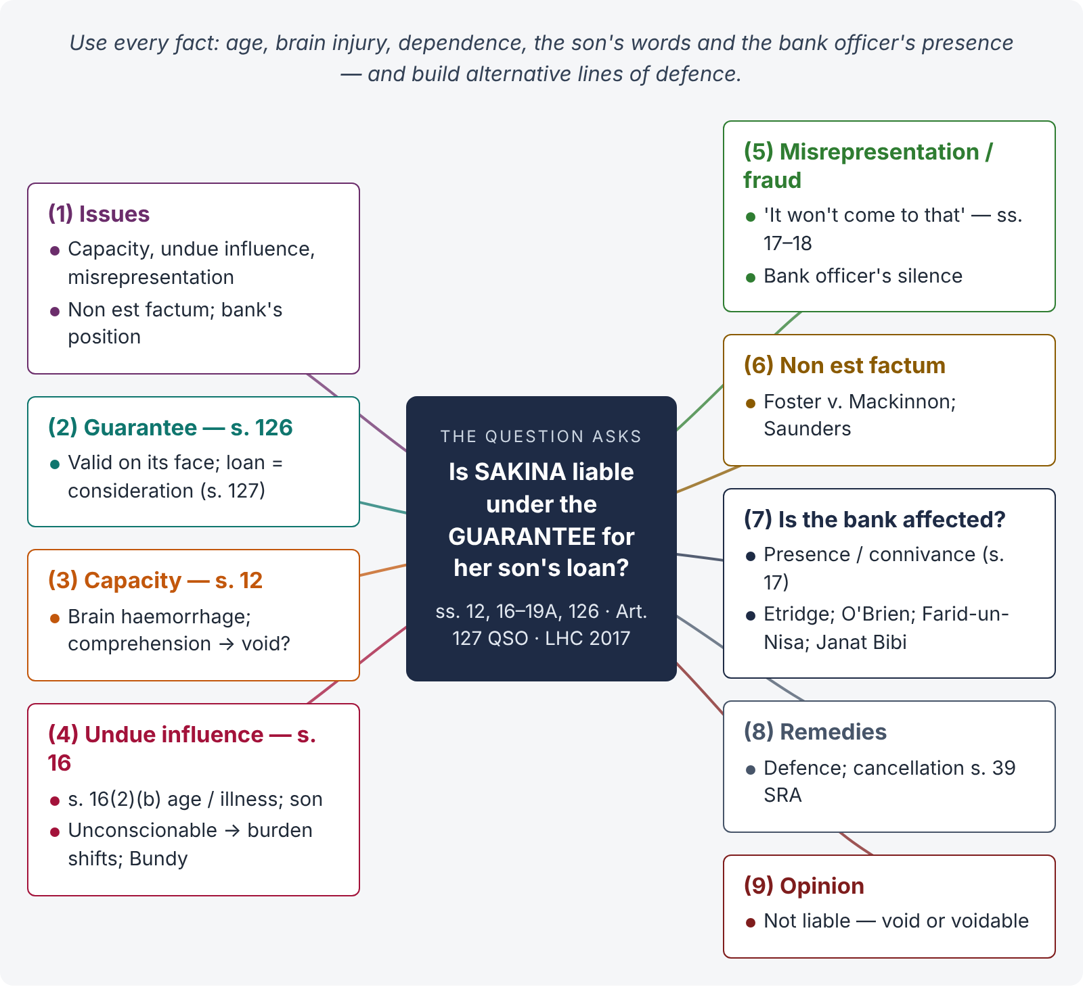
Figure 7 · The answer map: every branch is one numbered heading of the model answer below

Decoding the question
Every fact is a clue. Age 70, brain haemorrhage, memory loss, language comprehension difficulties → capacity (s. 12) and s. 16(2)(b). Passive and reliant → domination; son → relationship of influence. "I am sure it won't come to that" → misrepresentation of the nature and risk of the guarantee. Bank representative present, no independent advice → whether the bank is affected (Etridge). "Just sign here" → non est factum. Examine each line of defence, and give a clear opinion on whether she is liable.

The model answer

1. Issues
- Was a contract of guarantee formed (s. 126)?
- Did Sakina have capacity to contract (ss. 11–12)?
- Was her consent caused by undue influence (ss. 16, 19A)?
- Was it caused by misrepresentation or fraud (ss. 17–19)?
- Can she plead non est factum?
- Is the bank affected by Aslam's conduct, given the circumstances?

2. The contract of guarantee
"A 'contract of guarantee' is a contract to perform the promise, or discharge the liability, of a third person in case of his default" (s. 126). The loan to Aslam is sufficient consideration for the surety (s. 127). On its face, the deed signed by Sakina is a valid guarantee for Rs. 20 million. The question is whether it binds her. (Guarantee is studied in full in Topic 4.)

3. Capacity — s. 12
A person is of sound mind for contracting if, at the time, she is "capable of understanding it and of forming a rational judgment as to its effect upon [her] interests" (s. 12). Sakina has suffered a major brain haemorrhage, has lost most of her memories and has language comprehension difficulties. If medical evidence shows she could not understand the deed or judge its effect on her interests, she was incompetent, and the guarantee is void (ss. 10–12; Mohori Bibee principle). The burden lies on her to prove unsoundness, but these facts give her a strong case.

4. Undue influence — s. 16

i) Position to dominate
Under s. 16(2)(b), a person is deemed to be in a position to dominate where he contracts with a person "whose mental capacity is temporarily or permanently affected by reason of age, illness, or mental or bodily distress". Sakina is 70, brain-injured, passive, and was reliant on her family. Her son — on whom she would naturally rely after her husband's death — clearly had influence over her will.

ii) Unfair advantage
The guarantee exposed her (and possibly her property) to liability for Rs. 20 million for a risky new business, with no benefit to her. On its face it is unconscionable (s. 16(3)).

iii) Burden of proof
Since the transaction is unconscionable and the dominant party was in a position to dominate, "the burden of proving that such contract was not induced by undue influence shall lie upon the person in a position to dominate" (s. 16(3)). Article 127 of the Qanun-e-Shahadat 1984 also places on a person in active confidence the burden of proving good faith. The bank, claiming under the deed, must show she acted freely with full understanding.

iv) Authority
Raghunath Prasad v. Sarju Prasad ((1923) 51 IA 101, PC): domination, unfair use, and the shifting burden. Lloyds Bank v. Bundy ([1975] QB 326): an elderly farmer's guarantee of his son's company debts, given on the bank manager's word without independent advice, was set aside.

5. Misrepresentation and fraud — ss. 17–18
Aslam told her that the bank "just wants to make sure that everything will be okay" and "I am sure it won't come to that". This misstated the nature and risk of a guarantee — a binding promise to pay Rs. 20 million on default — as a mere formality. If Aslam believed it, it is misrepresentation (s. 18(1), and s. 18(3) — innocently causing a mistake as to the substance of the agreement); if he knew better, it is fraud (s. 17(1)). The bank representative was present and did not correct it; his silence, where the circumstances made it his duty to speak, may itself be fraudulent (s. 17 Explanation). Her consent is therefore voidable (s. 19). The s. 19 Exception (means of discovering the truth with ordinary diligence) does not help the bank: given her comprehension difficulties, she could not discover the truth with ordinary diligence.

6. Non est factum
If Sakina did not understand that the document was a guarantee at all, she may plead non est factum — "it is not my deed" (Foster v. Mackinnon, (1869) LR 4 CP 704). Under Saunders v. Anglia Building Society ([1971] AC 1004), the plea succeeds only if the document was radically different from what she believed and she was not careless. Given her disability and her son's description of it as a formality, this plea is arguable, and it would make the deed void.

7. Is the bank affected?
The bank will argue that Aslam's undue influence and misrepresentation are his wrongs, not the bank's. But:
- Agency / presence. The bank's representative was present, took part in obtaining the signature, and knew the circumstances (s. 17 covers fraud committed "with his connivance, or by his agent").
- Put on inquiry. In Royal Bank of Scotland v. Etridge (No. 2) ([2001] UKHL 44) and Barclays Bank v. O'Brien ([1994] 1 AC 180), a bank taking a guarantee from a person in a non-commercial relationship with the debtor (wife, elderly parent) is put on inquiry. It must take reasonable steps to ensure the surety understood the transaction — normally through independent legal advice. The bank did nothing of the kind.
- Pardanashin / illiterate women rule. Pakistani courts protect old, illiterate or dependent women. The person relying on the deed must prove that it was explained to her, that she understood it, and that she had independent advice (Farid-un-Nisa v. Mukhtar Ahmad, (1925) 52 IA 342, PC; Mst. Janat Bibi v. Sikandar Ali, PLD 1990 SC 642). Sakina, an elderly, injured village woman, falls squarely within this protection.
The bank therefore takes subject to the undue influence and misrepresentation, and cannot enforce the guarantee.

8. Remedies
Sakina may resist any suit on the guarantee, and may sue for cancellation of the deed (s. 39, Specific Relief Act) or a declaration that it is void or voidable and has been avoided. Rescission is communicated like a proposal (s. 66). As she received no benefit, there is nothing to restore under s. 64 or s. 19A.

9. Opinion
Sakina is not liable under the guarantee. On the facts, the deed is void if she lacked capacity (s. 12) or can establish non est factum; and in any case it is voidable at her option for undue influence (ss. 16, 19A) and misrepresentation (ss. 18, 19), which bind the bank because its representative was present and it failed to ensure that she received independent advice (Etridge; Farid-un-Nisa). The burden lies on the bank to prove otherwise (s. 16(3); Art. 127 QSO), which on these facts it cannot discharge.

Why this answer scores
- It uses every fact: age, injury, comprehension, dependence, the son's words, and the bank officer's presence.
- It builds alternative lines of defence — capacity, undue influence, misrepresentation, non est factum — so the conclusion survives even if one fails.
- It tackles the hardest point: why the bank, not just the son, is affected (Etridge, O'Brien, s. 17 "connivance or agent").
- The Pakistani protection of dependent women and Art. 127 QSO give it local authority.

Answer 8 · "Consideration" and "object" — the difference, and when they are lawful (LHC ASJ 2020)
AT A GLANCE · LHC ADDITIONAL DISTRICT AND SESSIONS JUDGES EXAMINATION 2020 · CIVIL LAW-I · Q. 1 · 20 MARKS
Discuss and explain in light of the relevant statutory provisions, the difference between "consideration" and "objects" with reference to an agreement if any, and in what circumstances can they be considered lawful?

The answer map
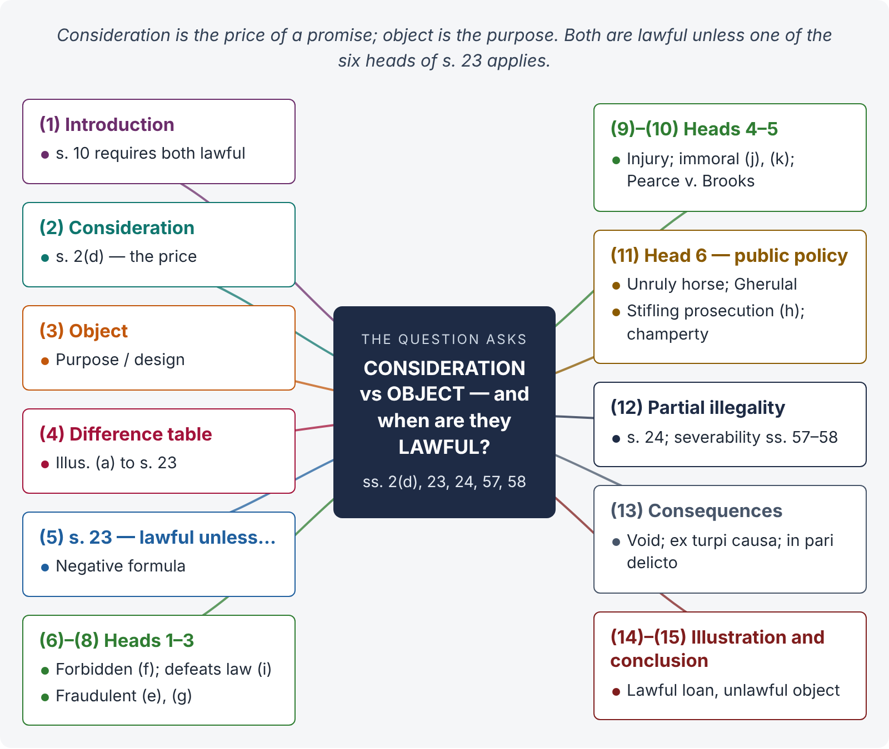
Figure 8 · The answer map: every branch is one numbered heading of the model answer below

Decoding the question
Two parts: (i) define and distinguish consideration (s. 2(d)) and object (purpose — s. 23), showing that they may coincide or differ; (ii) explain s. 23 — when they are lawful and when unlawful — with the six heads, the statutory illustrations, cases, and the effect (void; s. 24 partial illegality; ss. 57–58 severability). "In what circumstances can they be considered lawful" invites you to state s. 23's negative formula: lawful unless one of the heads applies.

The model answer

1. Introduction
Section 10 requires that a contract be made "for a lawful consideration and with a lawful object". The Act treats both under one section — s. 23 — but they are different ideas.

2. Consideration — meaning
"When, at the desire of the promisor, the promisee or any other person has done or abstained from doing, or does or abstains from doing, or promises to do or to abstain from doing, something, such act or abstinence or promise is called a consideration for the promise" (s. 2(d)). It is the price or quid pro quo of a promise — what is given in exchange.

3. Object — meaning
The Act does not define "object". It means the purpose or design of the agreement — what the parties intend to achieve by it. In most contracts the object is the performance itself (e.g., transfer of a house for money), but sometimes the parties share an ulterior purpose (e.g., money lent so that the borrower may bribe an official).

4. Difference between consideration and object
Point | Consideration | Object
Meaning | The price of the promise — what each party gives | The purpose or design of the agreement
Definition | s. 2(d) | Not defined; understood from s. 23
Question it answers | "What do I get for my promise?" | "Why are we making this agreement?"
Example | Rs. 500,000 paid as a loan | To use the money for bribery
Can it be lawful while the other is not? | Yes — lawful money for an unlawful purpose | Yes — unlawful consideration for a lawful purpose (e.g., paying a bribe to obtain a lawful licence)
Effect if unlawful | Agreement void (s. 23) | Agreement void (s. 23)

Illustration (a) to s. 23 shows the two together: "A agrees to sell his house to B for 10,000 rupees. Here B's promise to pay the sum of 10,000 rupees is the consideration for A's promise to sell the house, and A's promise to sell the house is the consideration for B's promise to pay the 10,000 rupees. These are lawful considerations." The object — sale of a house — is also lawful.

5. When are they lawful? — s. 23
"The consideration or object of an agreement is lawful, unless— it is forbidden by law; or is of such a nature that, if permitted, it would defeat the provisions of any law; or is fraudulent; or involves or implies injury to the person or property of another; or the Court regards it as immoral, or opposed to public policy. In each of these cases, the consideration or object of an agreement is said to be unlawful. Every agreement of which the object or consideration is unlawful is void."
So consideration and object are lawful in every case except the six listed. The six heads follow.

6. Head 1 — forbidden by law
Prohibited by a statute or rule having the force of law, expressly or by implication. Illustration (f): A promises to obtain for B a post in the public service for Rs. 1,000 — void. Examples: smuggling, sale of narcotics, bribery.

7. Head 2 — defeating the provisions of any law
Lawful in form but evading a statute. Illustration (i): an estate sold for arrears of revenue; the law forbids the defaulter to buy; B buys under an understanding to reconvey to A — void, as it defeats the law.

8. Head 3 — fraudulent
Illustration (e): A, B and C agree to divide gains acquired by fraud — void. Illustration (g): an agent, without his principal's knowledge, takes money to obtain a lease of the principal's land for B — void (fraud on the principal).

9. Head 4 — injury to the person or property of another
"Injury" means a wrongful act — e.g., an agreement to publish a libel, to trespass, or a bond requiring the debtor to work without wages (bonded labour, now an offence under the Bonded Labour System (Abolition) Act 1992).

10. Head 5 — immoral
Illustration (j): A, B's mukhtar, promises to use his influence with B in favour of C for Rs. 1,000 — void. Illustration (k): A agrees to let her daughter to hire for concubinage — void, though perhaps not punishable. Pearce v. Brooks ((1866) LR 1 Ex 213): hire of a carriage to a prostitute for her trade — unenforceable.

11. Head 6 — opposed to public policy
Public policy is "a very unruly horse" (Richardson v. Mellish, (1824) 2 Bing 229), so courts apply only established heads (Gherulal Parakh v. Mahadeodas Maiya, AIR 1959 SC 781): trading with an enemy; stifling prosecution (illustration (h): dropping a robbery prosecution in return for restoring the value of stolen goods — void); interfering with the course of justice; sale of public offices; marriage brokerage; and unconscionable champerty (Ram Coomar Coondoo v. Chunder Canto Mookerjee, (1876) ILR 2 Cal 233, PC — fair litigation funding is not void in itself).

12. Partial unlawfulness — s. 24 and severability
"If any part of a single consideration for one or more objects, or any one or any part of any one of several considerations for a single object, is unlawful, the agreement is void" (s. 24). Illustration: a salary of Rs. 10,000 for superintending a legal indigo business and an illegal traffic — wholly void, as the consideration cannot be apportioned. But where the lawful and unlawful parts are severable, the lawful part stands (s. 57 — reciprocal promises, legal and illegal; s. 58 — alternative promise, the legal branch enforced).

13. Consequences of unlawfulness
- The agreement is void (s. 23).
- Ex turpi causa non oritur actio — no action on an illegal agreement (Holman v. Johnson, (1775) 1 Cowp 341).
- In pari delicto potior est conditio defendentis — money paid is generally not recoverable, except where the parties are not equally at fault or the plaintiff withdraws before the illegal purpose is carried out.
- Collateral transactions to an illegal agreement are also tainted.

14. Illustration
Waqas lends Zain Rs. 2 million, both knowing that Zain will use it to pay a bribe to secure a CDA plot allotment. The consideration (the loan) is lawful in itself, but the object (bribery) is forbidden by law and opposed to public policy. The agreement is void (s. 23); Waqas cannot sue to recover the loan (in pari delicto). Had Waqas lent the money for Zain's business without knowing of the bribery, the loan would be valid.

15. Conclusion
Consideration is what is given for a promise; object is the purpose of the agreement. Both must be lawful. Under s. 23 they are lawful unless forbidden by law, defeating any law, fraudulent, injurious, immoral or opposed to public policy — in which case the agreement is void, and under s. 24 even partial unlawfulness of a single, indivisible consideration taints the whole.

Why this answer scores
- It defines both terms separately and gives a difference table, which is the core of the question.
- It quotes s. 23 in full and organises the answer around its six heads, each with an illustration from the Act.
- s. 24 and ss. 57–58 show depth on partial illegality.
- The final example shows lawful consideration with an unlawful object — the distinction the examiner wants to see applied.

Answer 9 · Short notes on five concepts (LHC 2022)
AT A GLANCE · LAHORE HIGH COURT 2022 · CIVIL LAW-I · Q. 1 · 20 MARKS (4 marks each)
Define and write short notes and principles laid down the following by the apex courts of Pakistan in various judgments: (i) Difference between "agreement and contract"; (ii) difference between "void" and "voidable contract"; (iii) effect of "promise" and "reciprocal promises"; (iv) concept of "express" and "implied" authority in an arrangement of agency; (v) mistake of fact and its effect on the contract.

The answer map
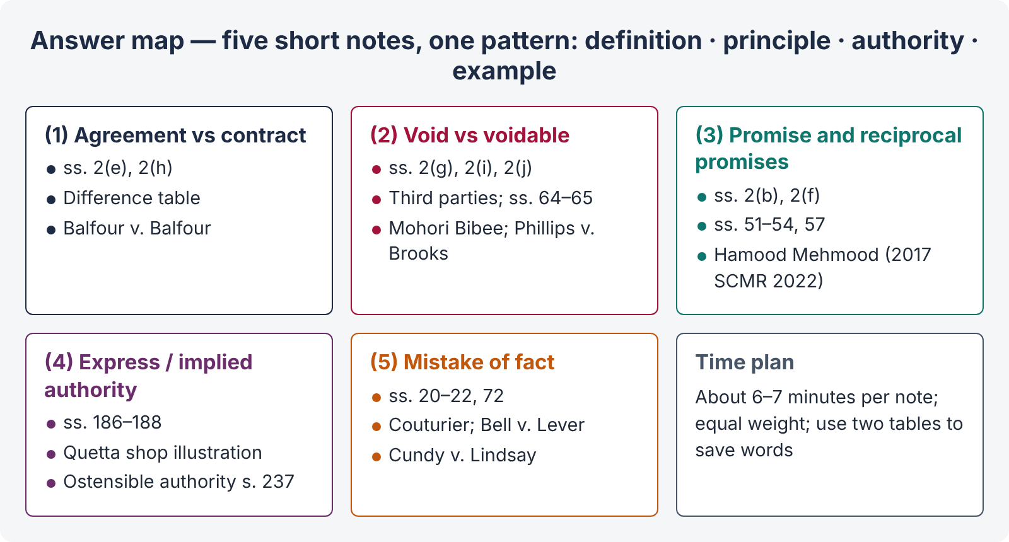
Figure 9 · The answer map: every branch is one numbered heading of the model answer below

Decoding the question
Five notes of about one page each. For each: definition from the Act, the key principle, one authority, and an example. Keep each note to the same structure so that none is short-changed. Note (iv) is from the law of agency (Topic 4) — answer it briefly from ss. 186–188.

The model answer

1. Agreement and contract

i) Definitions
Agreement: "Every promise and every set of promises, forming the consideration for each other, is an agreement" (s. 2(e)). Contract: "An agreement enforceable by law is a contract" (s. 2(h)).

ii) Differences
Point | Agreement | Contract
Scope | Wider — includes social, moral and void agreements | Narrower — only enforceable agreements
Elements | Promise + consideration | Agreement + s. 10 essentials
Legal obligation | Not necessarily | Always
Example | Promise to dine with a friend; wager | Sale of a car for a price

iii) Principle
"Every contract is an agreement, but every agreement is not a contract." An agreement without intention to create legal relations is not a contract (Balfour v. Balfour, [1919] 2 KB 571).

2. Void and voidable contracts

i) Definitions
"An agreement not enforceable by law is said to be void" (s. 2(g)). "An agreement which is enforceable by law at the option of one or more of the parties thereto, but not at the option of the other or others, is a voidable contract" (s. 2(i)). A contract becomes void when it ceases to be enforceable (s. 2(j)).

ii) Differences
Point | Void | Voidable
Validity | No legal effect from the start | Valid until avoided by the party entitled
Cause | Missing essential: incapacity, no consideration, unlawful object, s. 20 mistake, ss. 26–30 | Defective consent: coercion, undue influence, fraud, misrepresentation (ss. 19, 19A); s. 55
Third parties | Acquire no rights | Bona fide purchaser before avoidance protected
Restitution | s. 65 | s. 64

iii) Principle
A minor's agreement is void ab initio (Mohori Bibee v. Dharmodas Ghose, (1903) ILR 30 Cal 539, PC). A contract obtained by fraud is voidable, and a rogue's buyer who buys in good faith before avoidance gets good title (Phillips v. Brooks, [1919] 2 KB 243).

3. Promise and reciprocal promises

i) Definitions
"A proposal, when accepted, becomes a promise" (s. 2(b)). "Promises which form the consideration or part of the consideration for each other are called reciprocal promises" (s. 2(f)).

ii) Effect of reciprocal promises
- Simultaneous reciprocal promises — "no promisor need perform his promise unless the promisee is ready and willing to perform his reciprocal promise" (s. 51; e.g., delivery against payment).
- Order of performance — as fixed, or as the nature of the transaction requires (s. 52; a house must be built before the price is paid).
- Prevention — if one party prevents the other, the contract becomes voidable by the party prevented, with compensation (s. 53).
- Default in the first promise — the defaulter cannot claim the reciprocal performance and must compensate (s. 54).
- Legal and illegal reciprocal promises — the legal set is a contract, the illegal set void (s. 57).

iii) Principle
In suits for specific performance, a plaintiff must show that he has always been ready and willing to perform his part; Pakistani courts may require the buyer to deposit the balance price, and failure is fatal (Hamood Mehmood v. Mst. Shabana Ishaque, 2017 SCMR 2022).

4. Express and implied authority of an agent

i) Law
"The authority of an agent may be expressed or implied" (s. 186). "An authority is said to be express when it is given by words spoken or written. An authority is said to be implied when it is to be inferred from the circumstances of the case; and things spoken or written, or the ordinary course of dealing, may be accounted circumstances of the case" (s. 187).

ii) Extent
"An agent having an authority to do an act has authority to do every lawful thing which is necessary in order to do such act" (s. 188). An agent for carrying on a business has authority to do everything necessary for, or usually done in, that business.

iii) Example and principle
Illustration to s. 187: A owns a shop in Quetta, lives in Karachi, and visits the shop occasionally; the shop is managed by B, who is in the habit of ordering goods from C in A's name and paying for them out of A's funds with A's knowledge. B has an implied authority to order goods from C in A's name. The principal is bound by acts within the agent's actual (express or implied) authority, and by acts within his ostensible authority on which third parties rely (s. 237). (Full treatment: Topic 4.)

5. Mistake of fact and its effect

i) Law
"Where both the parties to an agreement are under a mistake as to a matter of fact essential to the agreement, the agreement is void" (s. 20). An erroneous opinion as to value is not a mistake of fact (Explanation). A contract is not voidable merely because one party was under a mistake of fact (s. 22).

ii) Kinds and effects
- Bilateral, essential — void: subject matter already perished (illus. (a) cargo bound for Karachi lost; (b) horse dead) — Couturier v. Hastie ((1856) 5 HLC 673).
- Quality — not operative unless it makes the thing essentially different (Bell v. Lever Brothers, [1932] AC 161).
- Unilateral — no relief (s. 22; Smith v. Hughes, (1871) LR 6 QB 597), except identity where vital (Cundy v. Lindsay, (1878) 3 App Cas 459) and non est factum.
- Mistake of Pakistani law — no relief; foreign law is treated as fact (s. 21).
- Money paid under a mistake is recoverable (s. 72).

iii) Principle
The law voids an agreement only where the mistake destroys the very basis of consent; otherwise the security of contracts prevails.

Why this answer scores
- Five notes, equal weight, each with definition, principle, authority and example — easy for the examiner to mark.
- Tables for the two "difference" notes save words and show clarity.
- The agency note is answered briefly but accurately (ss. 186–188, 237) with a pointer to Topic 4.
- The question asks for "principles laid down by the apex courts" — each note cites a leading judgment, including a Pakistani Supreme Court case.

Answer 10 · Intention of the parties and the relative importance of contractual terms (KPHC 2026)
AT A GLANCE · KP HIGH COURT 2026 · CIVIL LAW-I · PART III · Q. 7 · 20 MARKS
The intentions of the contracting parties are the main factors in deciding on the relative importance of contractual terms. Discuss whether this is, in fact, the approach currently taken by the courts.

The answer map
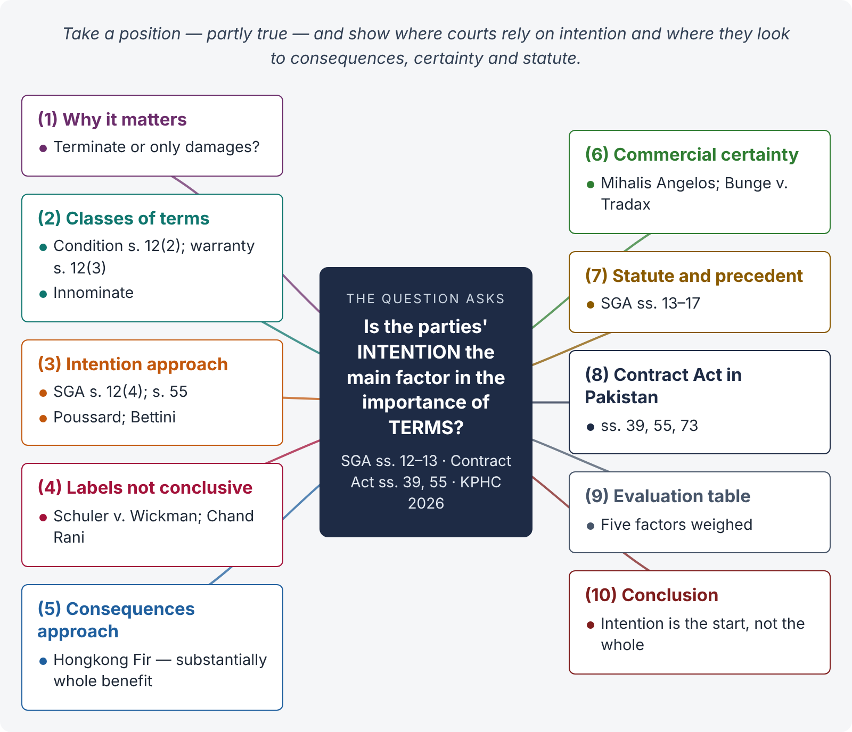
Figure 10 · The answer map: every branch is one numbered heading of the model answer below

Decoding the question
This is a critical essay. The statement is partly true. You must (i) explain why terms differ in importance — conditions, warranties and innominate terms; (ii) show where courts rely on intention (construction of the contract: SGA s. 12(4); s. 55 Contract Act; Poussard; Bettini); (iii) show where they look at other factors — the consequences of the breach (Hongkong Fir), commercial certainty (The Mihalis Angelos; Bunge v. Tradax), statute (SGA ss. 14–17), and the courts' refusal to be bound by the labels the parties used (Schuler v. Wickman); and (iv) conclude with a balanced view.

The model answer

1. Introduction — why the importance of a term matters
Every contract has terms of unequal weight. When a term is broken, the innocent party may wish to terminate the contract (and claim damages) or may be limited to damages while still performing. The classification of the term broken decides which. The statement says that the parties' intention decides that classification. The courts' actual approach is more mixed.

2. The classes of terms
- Condition — "a stipulation essential to the main purpose of the contract, the breach of which gives rise to a right to treat the contract as repudiated" (Sale of Goods Act 1930, s. 12(2)).
- Warranty — "a stipulation collateral to the main purpose of the contract, the breach of which gives rise to a claim for damages but not to a right to reject the goods and treat the contract as repudiated" (s. 12(3)).
- Innominate (intermediate) term — a term whose breach may be trivial or serious; the remedy depends on the gravity of the consequences (Hongkong Fir, below).

3. The intention-based (traditional) approach

i) Statute
"Whether a stipulation in a contract of sale is a condition or a warranty depends in each case on the construction of the contract. A stipulation may be a condition, though called a warranty in the contract" (SGA s. 12(4)). Construction means finding the intention of the parties, judged objectively from the contract as a whole.

ii) The Contract Act
Under s. 55, failure to perform at the fixed time makes the contract voidable only "if the intention of the parties was that time should be of the essence of the contract"; otherwise the promisee gets compensation only. Here the Act expressly makes intention the test.

iii) Classic cases
- Poussard v. Spiers and Pond ((1876) 1 QBD 410): a leading singer's absence from the opening night and first week went to the root of the engagement — condition; the producers could terminate.
- Bettini v. Gye ((1876) 1 QBD 183): a singer's late arrival for rehearsals — a subsidiary term (warranty); damages only.
In both cases the court asked what importance the parties must be taken to have attached to the term, judged at the time of contracting.

4. Express classification — labels are not conclusive
Parties may expressly state that a term is a "condition" or that "time is of the essence". Courts give great weight to this, but not conclusive weight.
L. Schuler AG v. Wickman Machine Tool Sales Ltd. ([1974] AC 235): a clause calling weekly visits to customers a "condition" did not entitle Schuler to terminate for a single missed visit. The House of Lords held that the more unreasonable the result, the more clearly the parties must show they intended it. The court looked behind the word to the true intention in the context of the whole contract.
Similarly, under s. 55, a clause saying "time is of the essence" in a sale of land may be displaced by other terms (e.g., provision for late payment with interest) or by conduct (Chand Rani v. Kamal Rani, (1993) 1 SCC 519). In sales of immovable property, the courts presume that time is not of the essence, even where a date is fixed.

5. The consequences-based approach — innominate terms
Hongkong Fir Shipping Co. v. Kawasaki Kisen Kaisha ([1962] 2 QB 26): the term "seaworthy" could be broken in many ways — from a missing nail to a sinking hull. Diplock LJ held that for such terms the court looks at the event — whether the breach deprived the innocent party of "substantially the whole benefit" intended. Twenty weeks' delay in a 24-month charter did not; the charterers had no right to terminate.
This approach does not depend on what the parties intended when contracting; it depends on what happened after breach. It reduces the risk of termination for trivial breaches on a falling market (a motive seen in cases like Arcos v. Ronaasen [1933] AC 470, where buyers rejected timber for a tiny deviation in thickness).

6. The return of certainty — commercial contracts
Courts later stressed certainty in mercantile contracts:
- The Mihalis Angelos ([1971] 1 QB 164): an "expected ready to load" clause is a condition; commercial parties need to know at once whether they can terminate.
- Bunge Corp. v. Tradax Export ([1981] 1 WLR 711, HL): time clauses in mercantile contracts are generally conditions, so that the innocent party need not wait to see how serious the consequences are.
Here, the classification rests on commercial policy and the type of contract as much as on the actual intention of the parties.

7. Classification by statute and precedent
- The Sale of Goods Act implies certain conditions — title, description, quality and fitness, sample (ss. 14–17) — whatever the parties thought.
- Some terms are classified by binding precedent (e.g., time of shipment in c.i.f. contracts).
- s. 13 SGA: a buyer may waive a condition or treat its breach as a breach of warranty; after acceptance of goods, a breach of condition must be treated as a breach of warranty — the law, not intention, decides.

8. The Contract Act's own approach in Pakistan
The Contract Act does not use the words "condition" and "warranty" but reaches the same results through:
- s. 39 — refusal or disablement to perform "in its entirety" allows termination; a partial breach gives compensation;
- s. 55 — intention that time be of the essence;
- s. 73 — compensation for every breach.
Pakistani courts therefore start from the intention of the parties (objectively construed), and look at the gravity of the breach and the nature of the contract (commercial vs land) in deciding whether termination is justified.

9. Evaluation
Factor | Role in the courts' approach
Intention (construction) | Starting point — SGA s. 12(4); s. 55; Poussard; Bettini
Labels used by the parties | Strong evidence but not conclusive — Schuler
Consequences of breach | Decisive for innominate terms — Hongkong Fir
Commercial certainty | Time clauses in mercantile contracts are conditions — Mihalis Angelos; Bunge v. Tradax
Statute and precedent | Implied conditions (SGA ss. 14–17); s. 13 SGA; presumptions on time in land sales

10. Conclusion
The statement is only partly accurate. Intention, objectively ascertained by construing the contract, remains the starting point — the SGA and s. 55 of the Contract Act say so expressly. But it is not the only, or always the main, factor. Courts decline to follow labels that produce unreasonable results (Schuler); for innominate terms they look at the consequences of the breach (Hongkong Fir); and in commercial contracts they classify terms with an eye to certainty (Bunge). The current approach is therefore a combination of intention, consequences and commercial policy.

Why this answer scores
- It takes a position — "partly true" — and proves it, which is what "discuss whether" requires.
- It moves historically: classic intention-based cases → innominate terms → return to certainty.
- It anchors the essay in the statutes in the syllabus (SGA ss. 12–13; Contract Act ss. 39, 55, 73).
- The evaluation table shows the examiner the whole argument in one view.

Answer 11 · Breach of a supply contract — damages, remoteness, mitigation and the penalty clause (practice problem)
AT A GLANCE · PRACTICE PROBLEM (EXAMINATION STYLE) · ss. 73–75 · 20 MARKS
Danish Textiles, Faisalabad, contracted with Khurram Engineering to supply and install a new dyeing machine for Rs. 15 million by 1 March 2026. Danish told Khurram at the time of contracting that it needed the machine to fulfil an export order from a Turkish buyer worth Rs. 30 million, on which it expected a profit of Rs. 4 million. The contract provided: "In case of delay, the supplier shall pay Rs. 500,000 per week of delay as liquidated damages." Danish paid Rs. 3 million as advance. The machine was installed on 1 May 2026 — eight weeks late. Danish lost the Turkish order. During the delay it also lost ordinary local work worth Rs. 600,000 in profit. Danish could have hired a similar machine for Rs. 200,000 a month, but did not. Danish claims Rs. 4,000,000 (the export profit) plus Rs. 4,000,000 under the clause. Advise.

The answer map
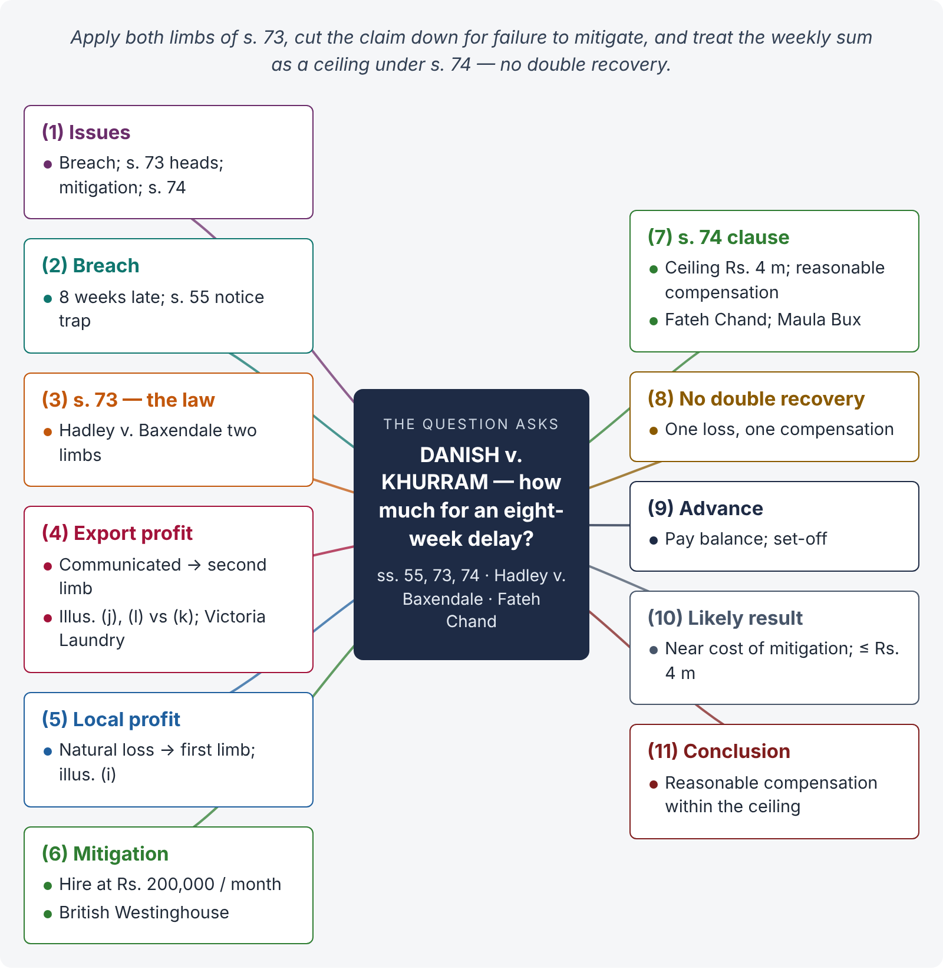
Figure 11 · The answer map: every branch is one numbered heading of the model answer below

Decoding the question
The problem tests s. 73 (the two limbs of Hadley v. Baxendale, communicated special circumstances, illustrations), the Explanation to s. 73 (mitigation — the hire option), and s. 74 (the "liquidated damages" clause — under Pakistani law a ceiling, not an automatic sum; Fateh Chand). The claim combines the two, so you must also deal with double recovery. End with a figure the court is likely to award.

The model answer

1. Issues
- Is Khurram in breach, and was time of the essence?
- Which losses are recoverable under s. 73 — the export profit and the local profit?
- What is the effect of Danish's failure to mitigate?
- What is the effect of the Rs. 500,000 per week clause under s. 74?
- Can Danish recover both the clause amount and the s. 73 damages?

2. Breach
Khurram promised installation by 1 March 2026 and installed on 1 May — eight weeks late. Danish accepted late performance. Under s. 55, if time was of the essence, the contract was voidable; but by accepting late performance Danish cannot claim compensation unless it gave notice of its intention to do so at the time of acceptance (s. 55, para 3). Assuming Danish reserved its rights (as a prudent party would, and as the claim suggests), it may claim compensation. Without such notice, the claim would fail — a point the answer must flag.

3. The law — s. 73
"…compensation for any loss or damage caused to him thereby, which naturally arose in the usual course of things from such breach, or which the parties knew, when they made the contract, to be likely to result from the breach of it. Such compensation is not to be given for any remote and indirect loss … Explanation.— In estimating the loss or damage …, the means which existed of remedying the inconvenience caused by the non-performance of the contract must be taken into account."
This is the rule in Hadley v. Baxendale ((1854) 9 Exch 341): (i) losses arising naturally; (ii) losses in the contemplation of both parties because of special circumstances communicated at the time of contracting.

4. The export profit — Rs. 4 million (second limb)
Danish told Khurram, at the time of contracting, that the machine was needed for a specific export order with an expected profit of Rs. 4 million. That loss was therefore within the parties' contemplation (s. 73, second limb). Compare:
- Illustration (j): where the seller is told the purpose of a purchase (to perform a contract with B), he is liable for the lost profit on that contract.
- Illustration (l): a builder informed of the owner's lease to C is liable for lost rent and compensation paid to C.
- Contrast illustration (k) and Victoria Laundry v. Newman Industries ([1949] 2 KB 528), where uncommunicated, exceptionally lucrative contracts were not recoverable.
Prima facie, the export profit is recoverable — subject to mitigation.

5. The local profit — Rs. 600,000 (first limb)
Loss of ordinary profits from a profit-earning machine during delay arises naturally in the usual course of things (Victoria Laundry — ordinary laundry profits recovered; illus. (i) — average profit of the mill during the delay). This loss is recoverable under the first limb — again subject to mitigation.

6. Mitigation — the hire option
Danish could have hired a similar machine for Rs. 200,000 a month — about Rs. 400,000 for the eight weeks — but did not. Under the Explanation to s. 73, the means of remedying the inconvenience "must be taken into account" (British Westinghouse Electric v. Underground Electric Railways, [1912] AC 673). Had Danish hired the machine:
- it could probably have fulfilled the export order and earned the Rs. 4 million profit; and
- it could have continued its local work.
Danish therefore cannot recover losses it reasonably could have avoided. Its recoverable loss is limited to what mitigation would have cost — the hire charges (about Rs. 400,000) plus any extra expenses reasonably incurred — unless Danish shows that hiring was not reasonably possible (e.g., no machine was in fact available in time, or installation of a hired machine would itself have taken too long). The burden of proving failure to mitigate is on the defendant, Khurram.

7. The "liquidated damages" clause — s. 74
"When a contract has been broken, if a sum is named in the contract as the amount to be paid in case of such breach … the party complaining of the breach is entitled, whether or not actual damage or loss is proved to have been caused thereby, to receive … reasonable compensation not exceeding the amount so named."
- Under s. 74, the distinction between penalty and liquidated damages does not matter; the named sum is a ceiling — here Rs. 4,000,000 (8 weeks × Rs. 500,000).
- The court awards only reasonable compensation within that ceiling (Fateh Chand v. Balkishan Dass, AIR 1963 SC 1405).
- The words "whether or not actual damage or loss is proved" relieve the claimant from proving the exact amount of loss, but the court must still be satisfied that the sum awarded is reasonable, having regard to the loss that resulted and the duty to mitigate (Maula Bux v. Union of India, AIR 1970 SC 1955 — where loss can be proved, it should be).

8. No double recovery
The s. 74 clause and the s. 73 claim compensate the same loss — the loss caused by delay. Danish cannot claim both Rs. 4 million under the clause and Rs. 4 million as export profit. Where the contract names a sum for the breach, s. 74 governs and the compensation cannot exceed the sum named (Rs. 4 million) for that breach.

9. The advance of Rs. 3 million
The contract was performed (late), and the advance is part of the price of Rs. 15 million. Danish must pay the balance (Rs. 12 million) and may set off the compensation awarded (O. VIII r. 6 CPC; legal set-off of an ascertained sum, or equitable set-off arising from the same transaction).

10. Likely result
Head | Likely outcome
Export profit Rs. 4,000,000 | In principle recoverable (communicated — second limb), but reduced for failure to mitigate
Local profit Rs. 600,000 | In principle recoverable (first limb), but avoidable by hiring
Mitigation | Recovery limited to the cost of hire (about Rs. 400,000) plus reasonable expenses, unless hiring was impracticable
s. 74 clause | Ceiling of Rs. 4,000,000; the court awards reasonable compensation within it
Double recovery | Not allowed — one compensation for the delay

A court is likely to award reasonable compensation in the region of the cost of mitigation plus reasonable incidental losses — far less than the Rs. 8 million claimed. If Danish proves that no substitute machine was available, the award could approach the Rs. 4 million ceiling, but cannot exceed it.

11. Conclusion
Khurram is liable for the eight-week delay (subject to Danish's reservation of rights under s. 55). The export profit was within the parties' contemplation and the local profit arose naturally (s. 73; Hadley v. Baxendale; Victoria Laundry). But Danish's failure to hire a substitute limits recovery to what reasonable mitigation would have cost (Explanation to s. 73). The weekly sum in the contract is only a ceiling under s. 74 (Fateh Chand), and the same loss cannot be recovered twice. Danish should receive reasonable compensation not exceeding Rs. 4 million, most likely close to the cost of mitigation.

Why this answer scores
- It applies both limbs of s. 73 to the right heads of loss, using the Act's illustrations (i), (j), (k), (l).
- It spots the mitigation fact and quantifies its effect — the point most candidates miss.
- It applies the Pakistani s. 74 (ceiling, not pre-estimate) instead of the English penalty / liquidated damages test.
- It deals with double recovery, the s. 55 notice trap and set-off — showing judicial thinking.

